**VISVESVARAYA TECHNOLOGICAL UNIVERSITY**

**“JnanaSangama”, Belgaum -590014, Karnataka.**



**LAB REPORT**

# on

OBJECT ORIENTED MODELLING AND DESIGN

***Submitted by***

# YASHWANTH KIRAN S (1BM19CS187)

***in partial fulfillment for the award of the degree of***

**BACHELOR OF ENGINEERING**

***in***

**COMPUTER SCIENCE AND ENGINEERING**



**B.M.S. COLLEGE OF ENGINEERING**

**(Autonomous Institution under VTU)**

**BENGALURU-560019**

# April-2022 to July-2022

**B. M. S. College of Engineering,**

**Bull Temple Road, Bangalore 560019**

(Affiliated To Visvesvaraya Technological University, Belgaum)

**Department of Computer Science and Engineering**



**CERTIFICATE**

This is to certify that the Lab work entitled “Lab report” carried out by **YASHWANTH KIRAN S (1BM19CS187),** who is bonafide student of **B. M. S. College of Engineering.** It is in partial fulfillment for the award of **Bachelor of Engineering in Computer Science and Engineering** of the Visvesvaraya Technological University, Belgaum during the academic year 2021-2022. The Lab report has been approved as it satisfies the academic requirements in respect of a **“OBJECT ORIENTED MODELLING AND DESIGN”** work prescribed for the said degree.

**Dr. Shyamala G Dr. Jyothi S Nayak**

Associate Professor Professor and Head

Department of CSE Department of CSE

BMSCE, Bengaluru BMSCE, Bengaluru

`

**Table of Contents**

|  |
| --- |
| 1. College Information System |
| 2. Hostel Management System |
| 3. Stock Maintenance System |
| 4. Coffee Vending Machine |
| 5. Online Shopping System |
| 6. Railway reservation system |
| 7. Graphics Editor |

# College Information System

## SRS – Software Requirements Specification

A centralized approach and system for college to manage their daily activities which includes management of employees, students, books and library records, parent details, assignments, admission process, results and reports, exams, events, attendance, timetable, fees and other reports. It provides one point access to manage these wide range of activities both effectively and efficiently.

1. The system will be used by four people – Admin, Teacher, Librarian, Student.
2. Admin can log-in using valid credentials and perform various tasks such as adding a teacher, a student, a librarian, and can also view them.
3. Admin can also add time table and event details. System allows admin to view book request received from librarian.
4. Teacher can log-in and perform various tasks such as adding assignments and marking attendance, uploading result and view events.
5. Librarian can log-in and perform tasks such as adding single and multiple books, view added books, requesting book, issuing books to students, returning issued books from students and viewing events.
6. Student can access the system by providing valid credentials and access modules such as viewing their own profile, viewing books, viewing time table, assignment, attendance, result and event.
7. Super admin is the root node who adds colleges into the system with the valid details. They can view/delete a college from the system.

Class Diagram

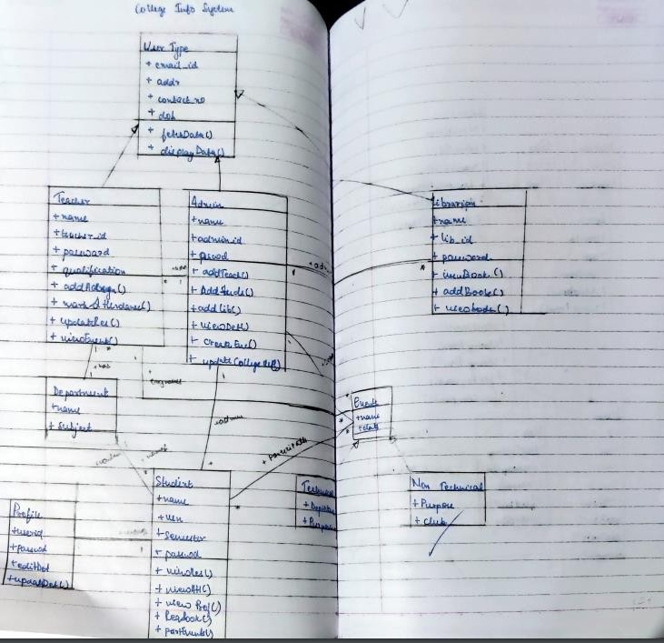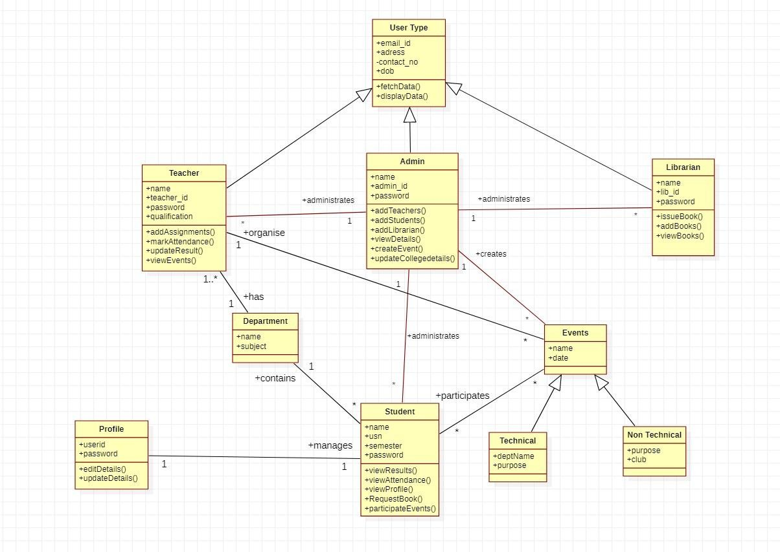

* State Diagram

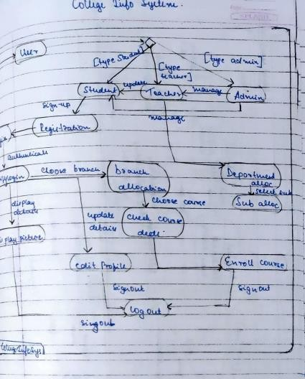

Here the students can register for a course by checking the availability of the course and choose a branch by checking the availability of the seats>Enrolment process is covered. Teacher department allocation is represented. Admin can manage both student and teacher.

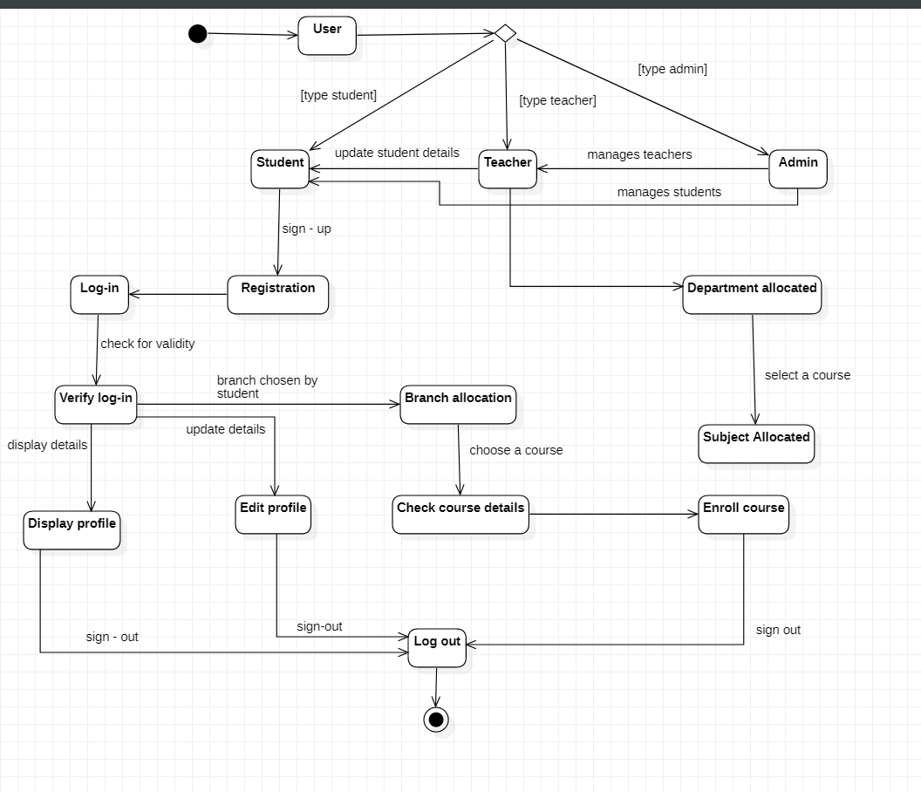

* Use Case Diagram
* 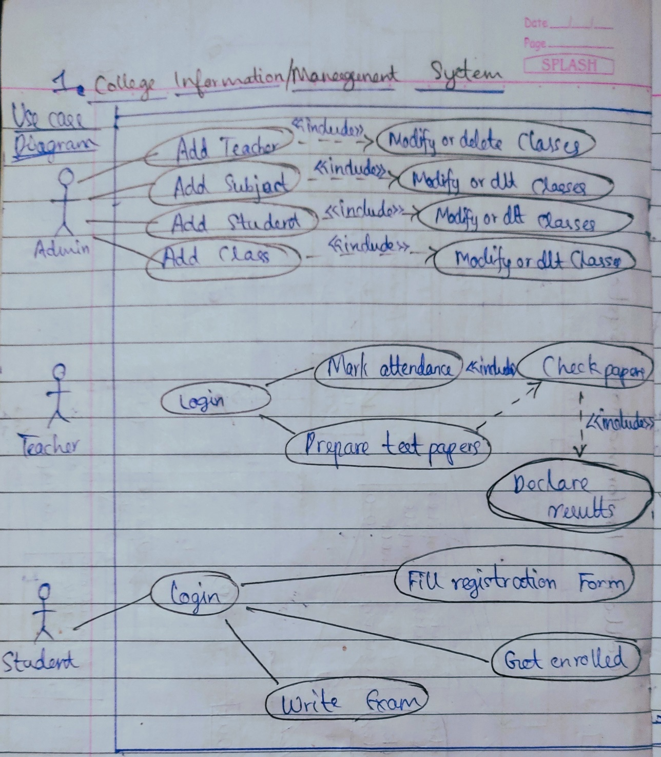

The teacher attendance and test marking functionality is depicted. Students file registration ,enrollment and exam writing functionality is depicted

Advanced

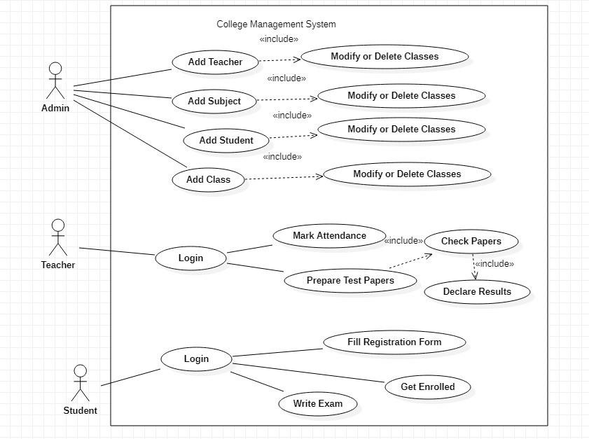

## Sequence Diagram

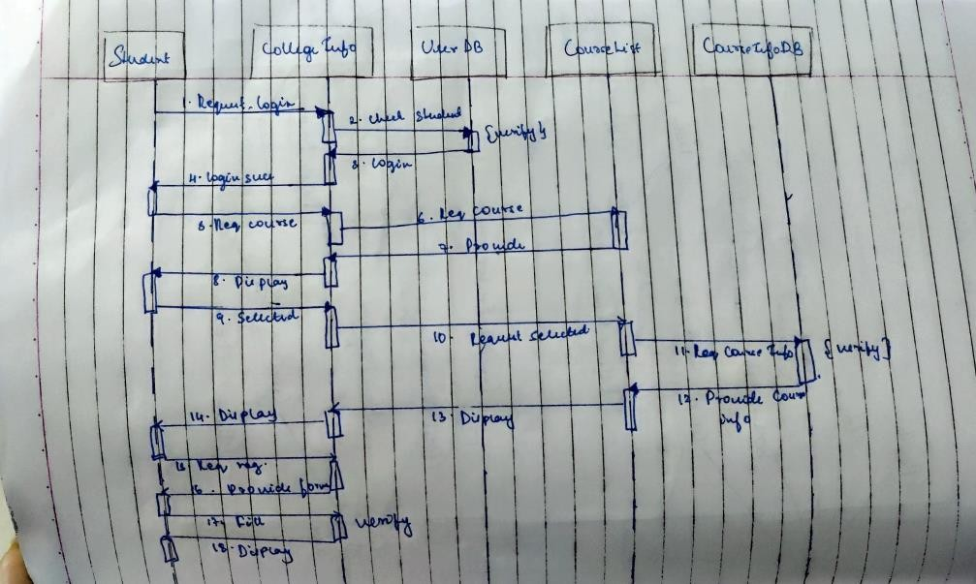

Students course registration sequence is depicted in the sequence diagram as the scenario considered Advanced

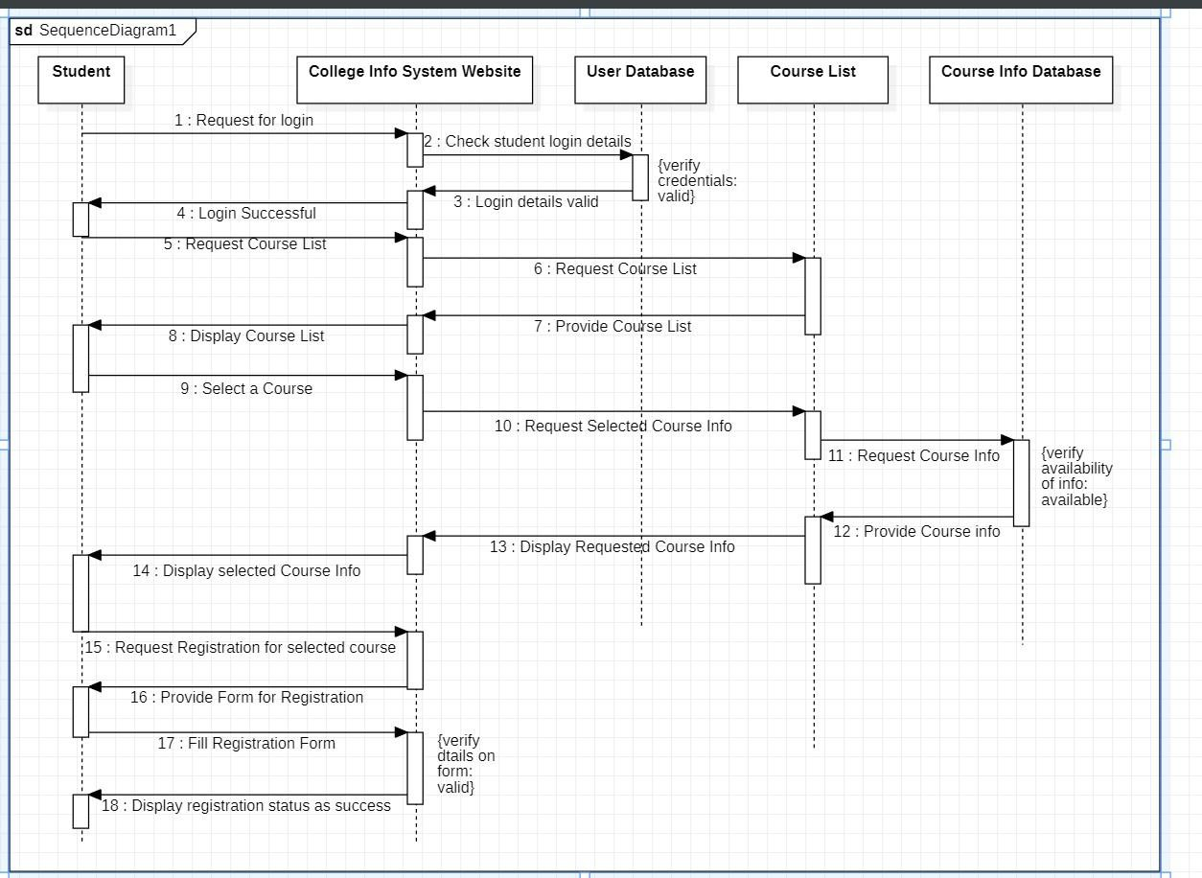

* Activity Diagram

Students course registration is considered for activity diagram depicting the steps followed to register the student

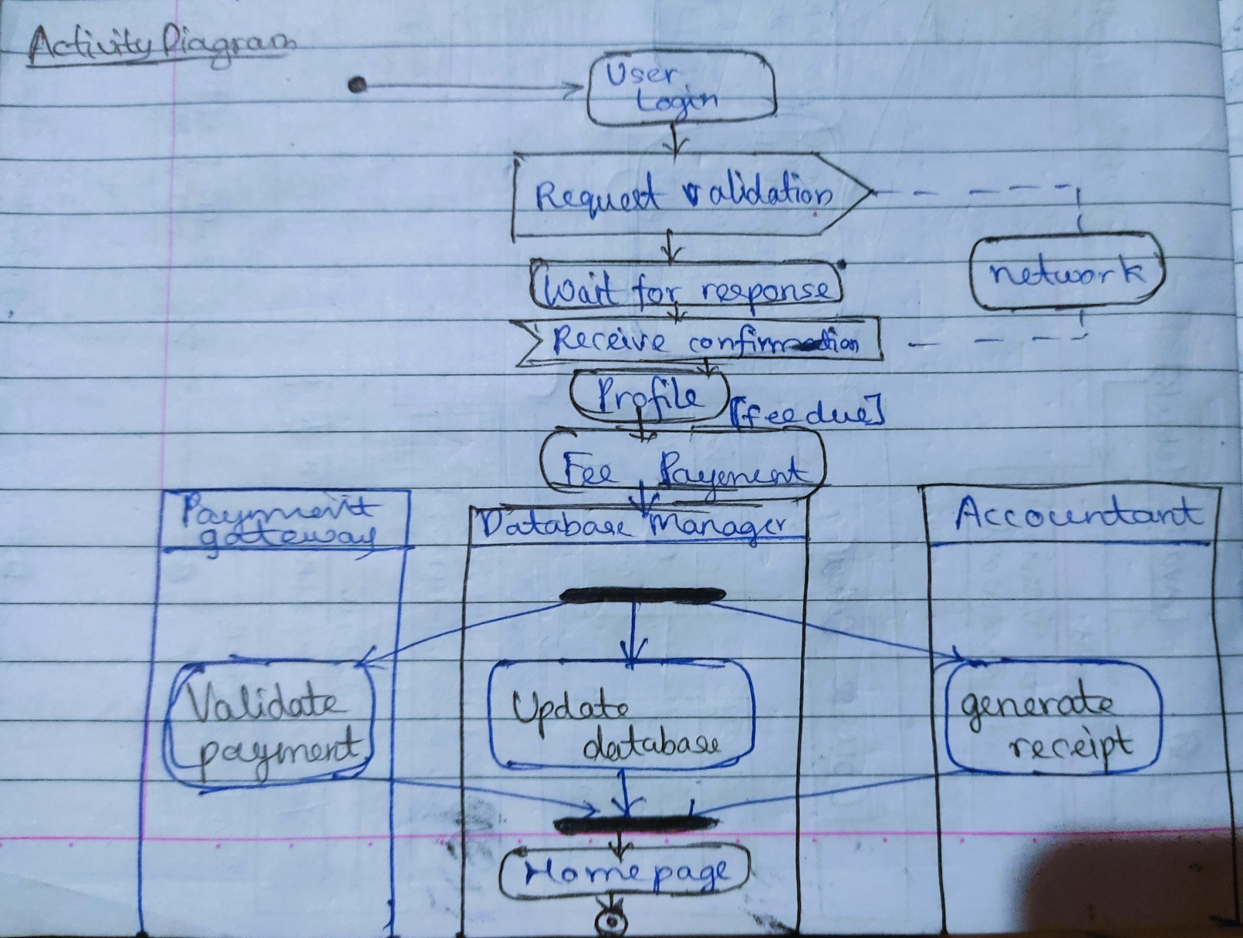

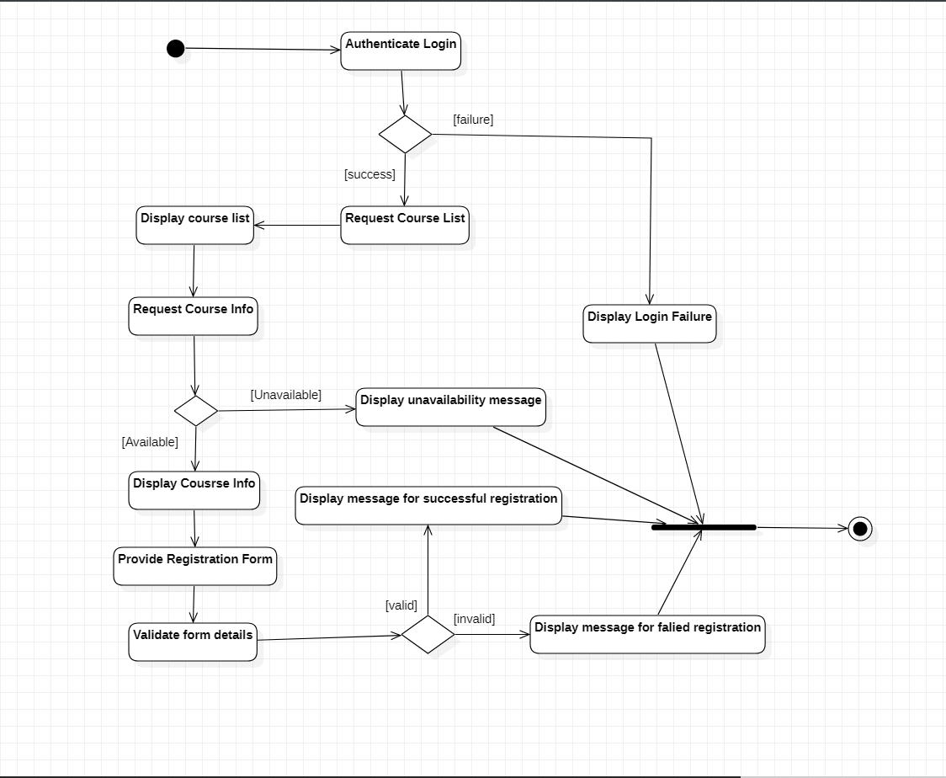

# Hostel Management System

## SRS – Software Requirements Specification

The purpose of Hostel Management System is to carry out different operations of a hostel. This system will provide ease, comfort of use to the staff of the hostel by performing all work on computer. It helps to manage student and staff records.

1. Admin can login using credentials provided to him.
2. Admin can approve room allotments to students, maintain mess and other departments.
3. Students can login using the credential provided and can give feedback about staff, can search for hostel, can change rooms and mess and make payments and can complaint to management if any.
4. Mess manager can update the menu list.
5. Management acts on the complaint made by students, collects fees and review the feedback given by students.
6. Mess managers can review the mess feedback.
7. Admin also maintains attendance of staff.
8. The system should be easy to handle.
9. System should give expected performance results.
10. The response time should be small.
11. Students can login using the credential provided and can give feedback about staff, can search for hostel, can change rooms and mess and make payments and can complaint to management if any.
12. Mess manager can update the menu list.
13. Management acts on the complaint made by students, collects fees and review the feedback given by students.
14. Mess managers can review the mess feedback.
15. Admin also maintains attendance of staff.
16. The system should be easy to handle.
17. System should give expected performance results.
18. The response time should be small.

## Class Diagram

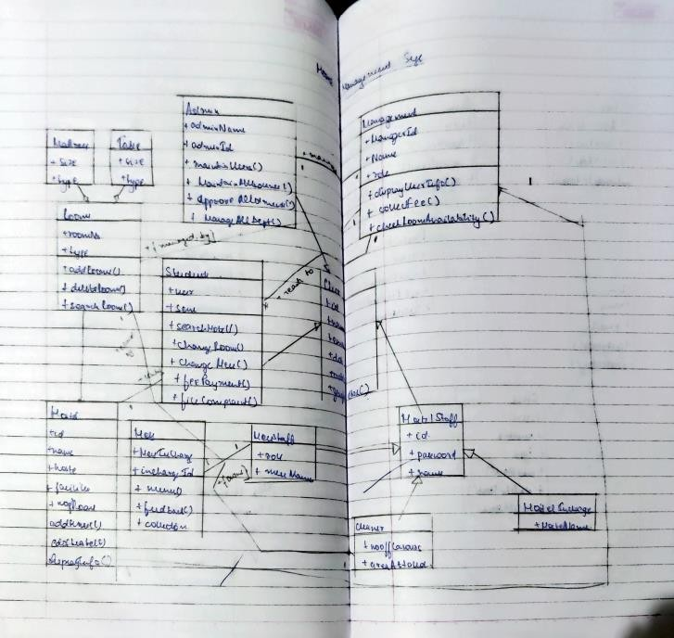

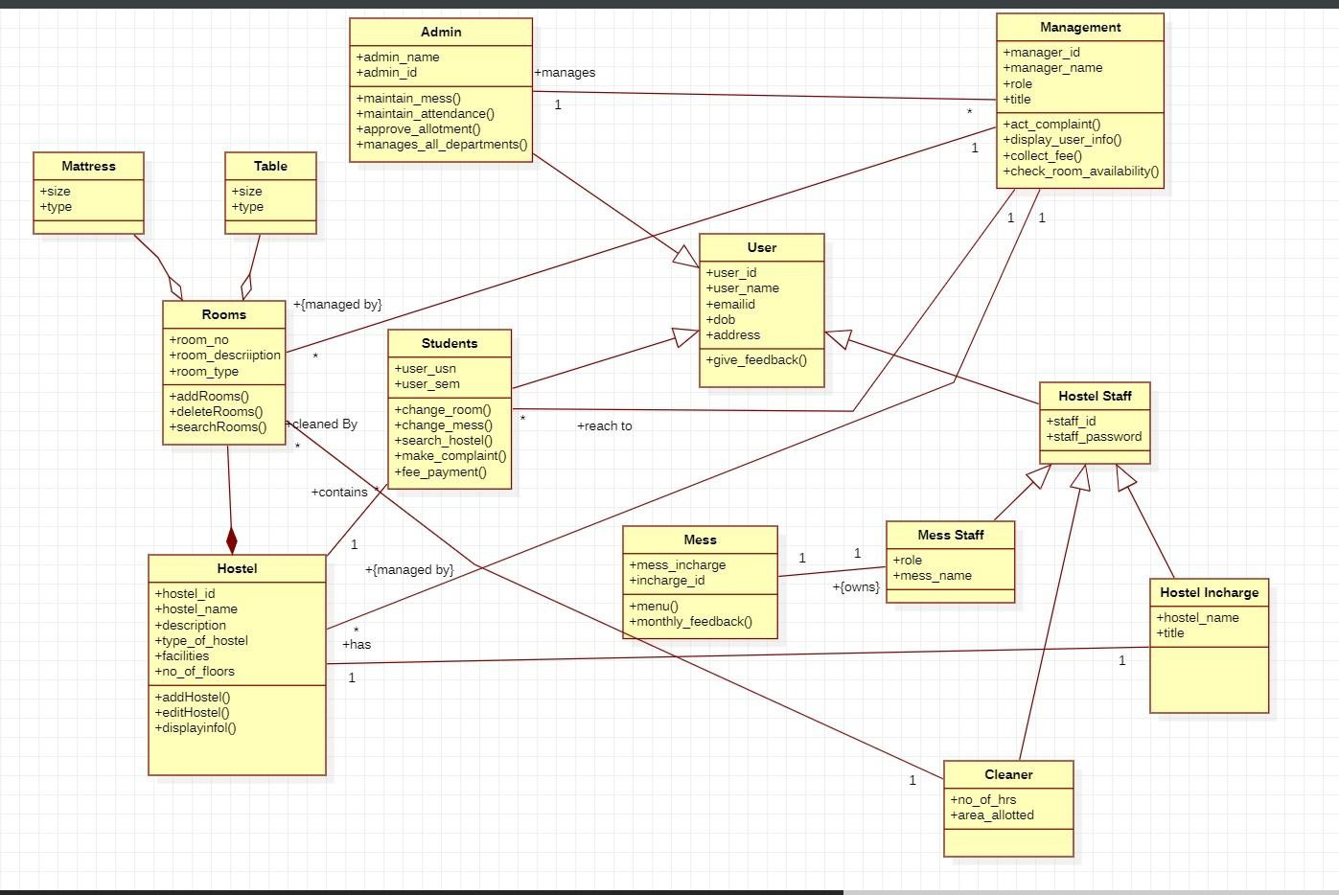

## State Diagram

The advanced use case diagram has extra functionalities which includes extends, includes and generalization. The edit hostel info use case extends add room use case, collect fee use case includes verify student, add room use case includes delete room use case.

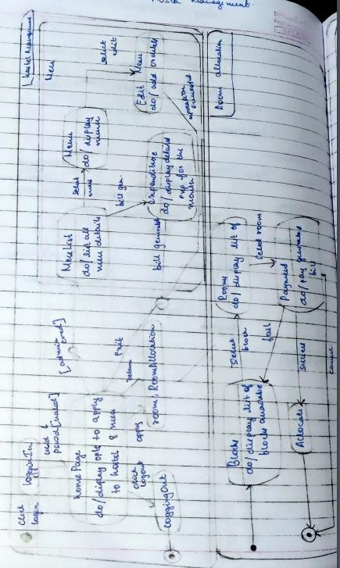

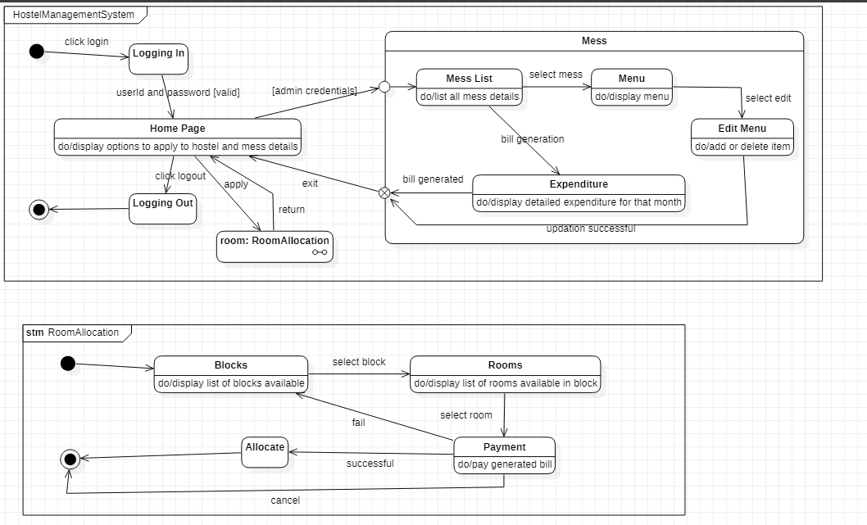

## Use Case

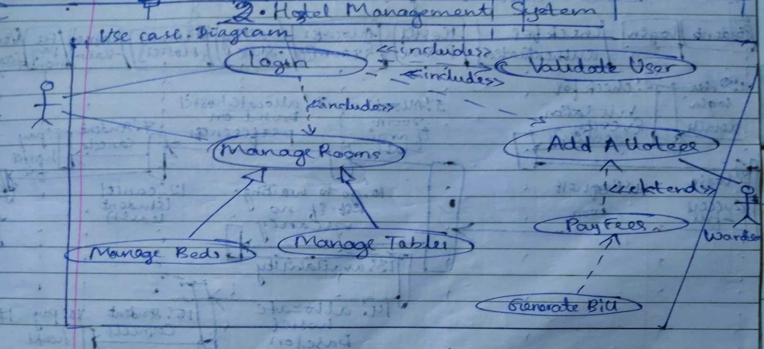

Advanced

The lifeline is the dotted line and the rectangles represent the period of time the object is Executing and is hence called activation.

The Login actor has self-message to check with the registration of the student.

Async and sync signal replies (dotted line) are used to reply back with specificity to the object.

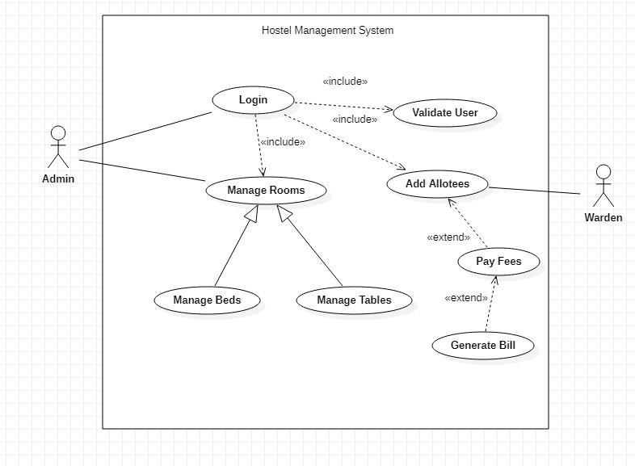

* Sequence Diagram

The lifeline is the dotted line and the rectangles represent the period of time the object is Executing and is hence called activation.

The Login actor has self-message to check with the registration of the student.

Async and sync signal replies (dotted line) are used to reply back with specificity to the object.

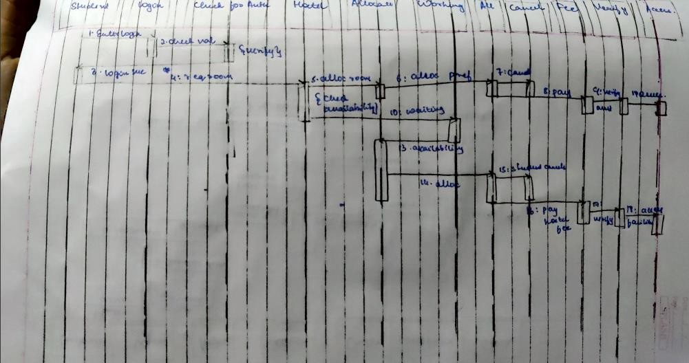

Advanced

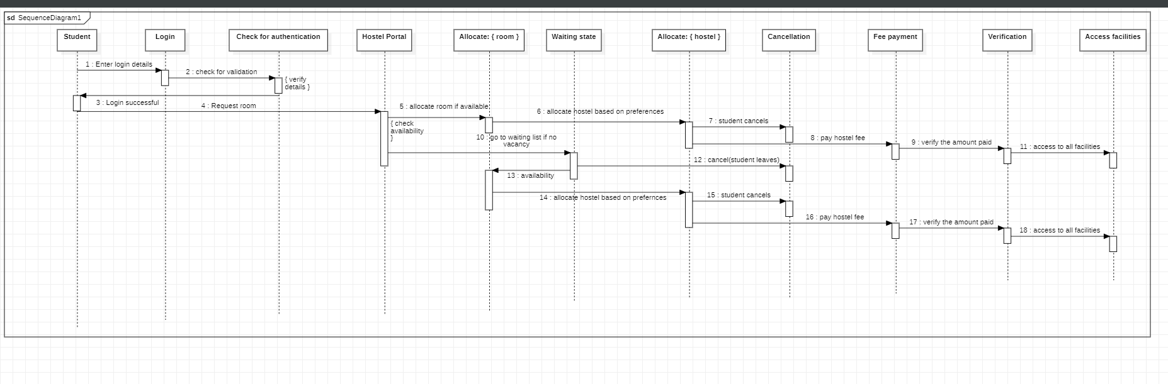

## Activity Diagram

Room allocation scenario is considered where student logins in checks the database and checks if the room is available and then check with department and gets the room allocated

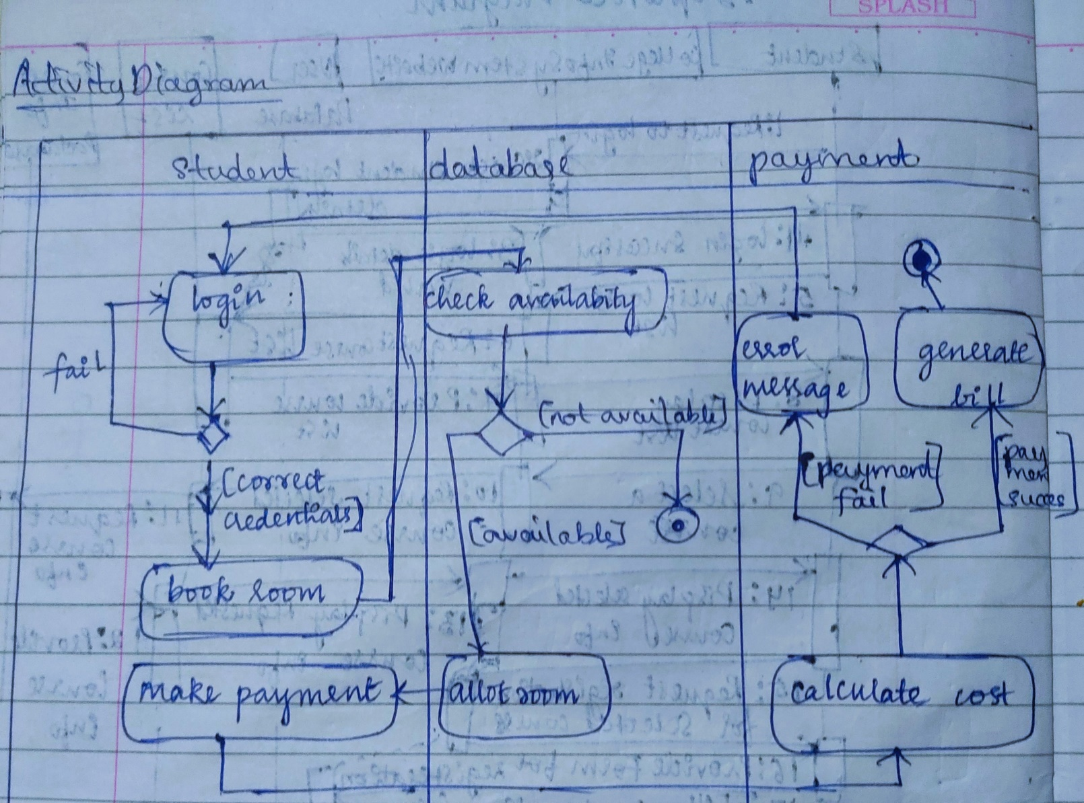

Advanced

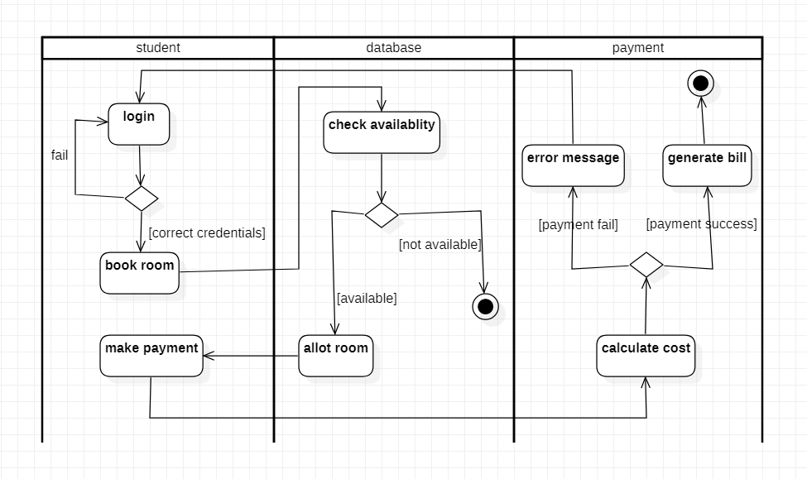

# Stock Maintenance System

## SRS – Software Requirements Specification

The stock maintenance system will allow the employees to record information of the items available in the store and generate reports based on the total amount of sales. The new system will have a windows-based desktop interface to allow employees to enter the information of sales, purchase orders, change employee preferences and create reports.

The system retains information on all the items in the shop. The system retains the records of the cost, expiry date, vendor details, Discount, quantity. The employee maintains the information of the sale of the item. He can add the items at the right time and update the database. The customer can view the availability of the required items and the price of the items. The customer can just view them but cannot make any changes.

The process of stock maintenance system is that the customer logs in to the particular site to place the order for the customer product.

The stock maintenance system is described sequentially through steps

* 1. The customer logs in to the particular site.
  2. They fill the customer details.
  3. They place the orders for their product.
  4. The vendor logs in and views the customer details and order

## Class Diagram

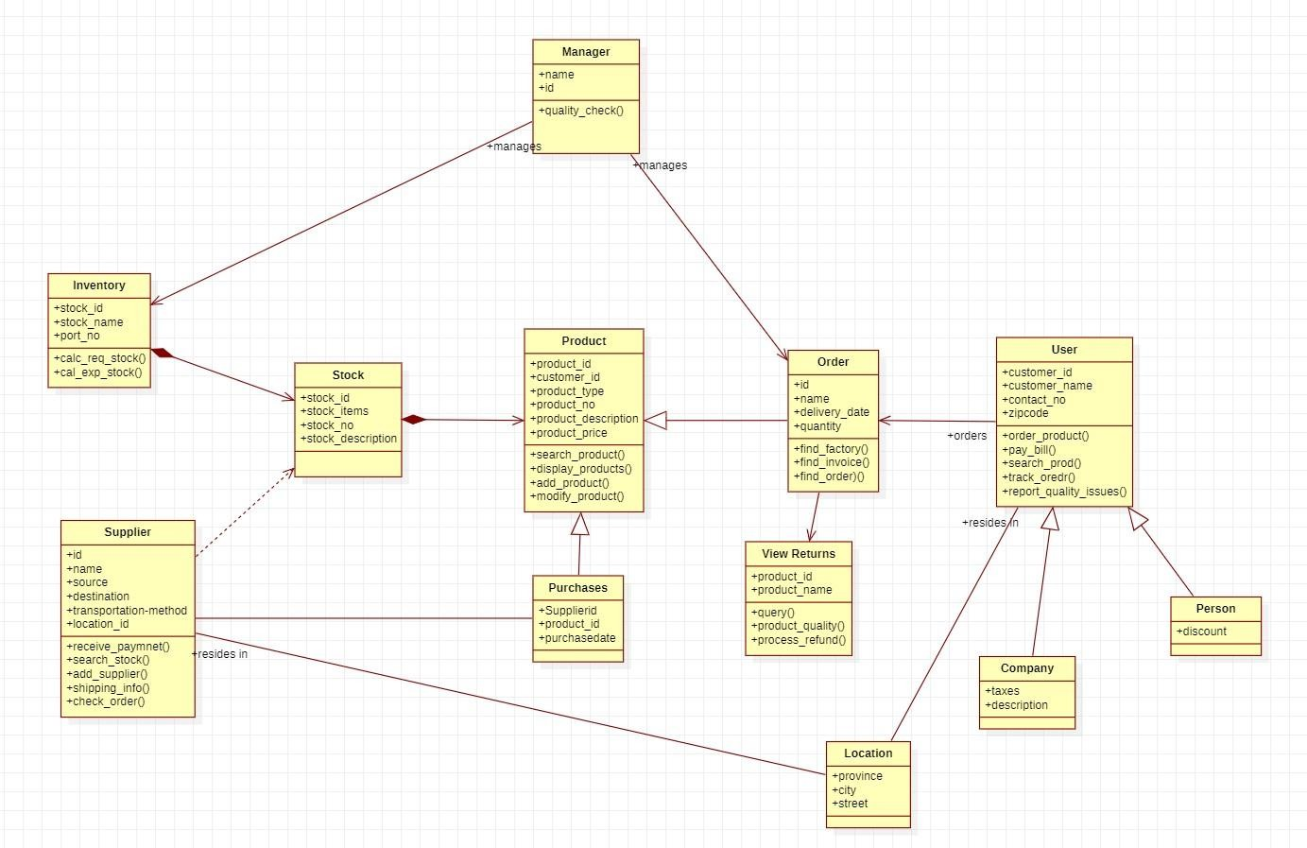

## State Diagram

The diagram shows logging into the page, checking stock inventory, selling stocks, maintaining records of stocks along with enabling owner to order stocks, check stock status and sell stocks.

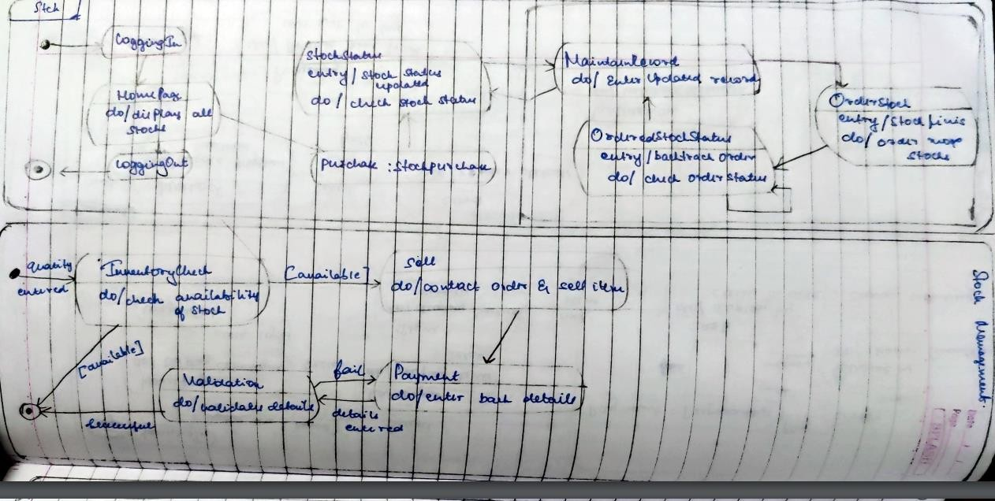

Fig 3.2

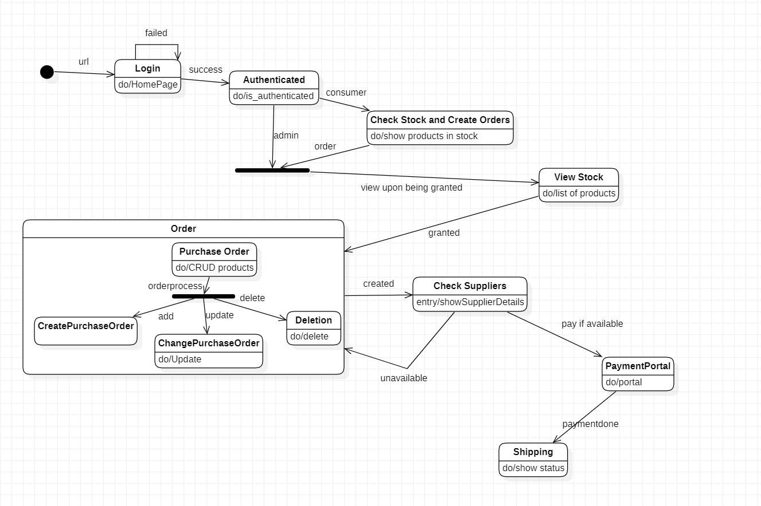

Use Case Diagram

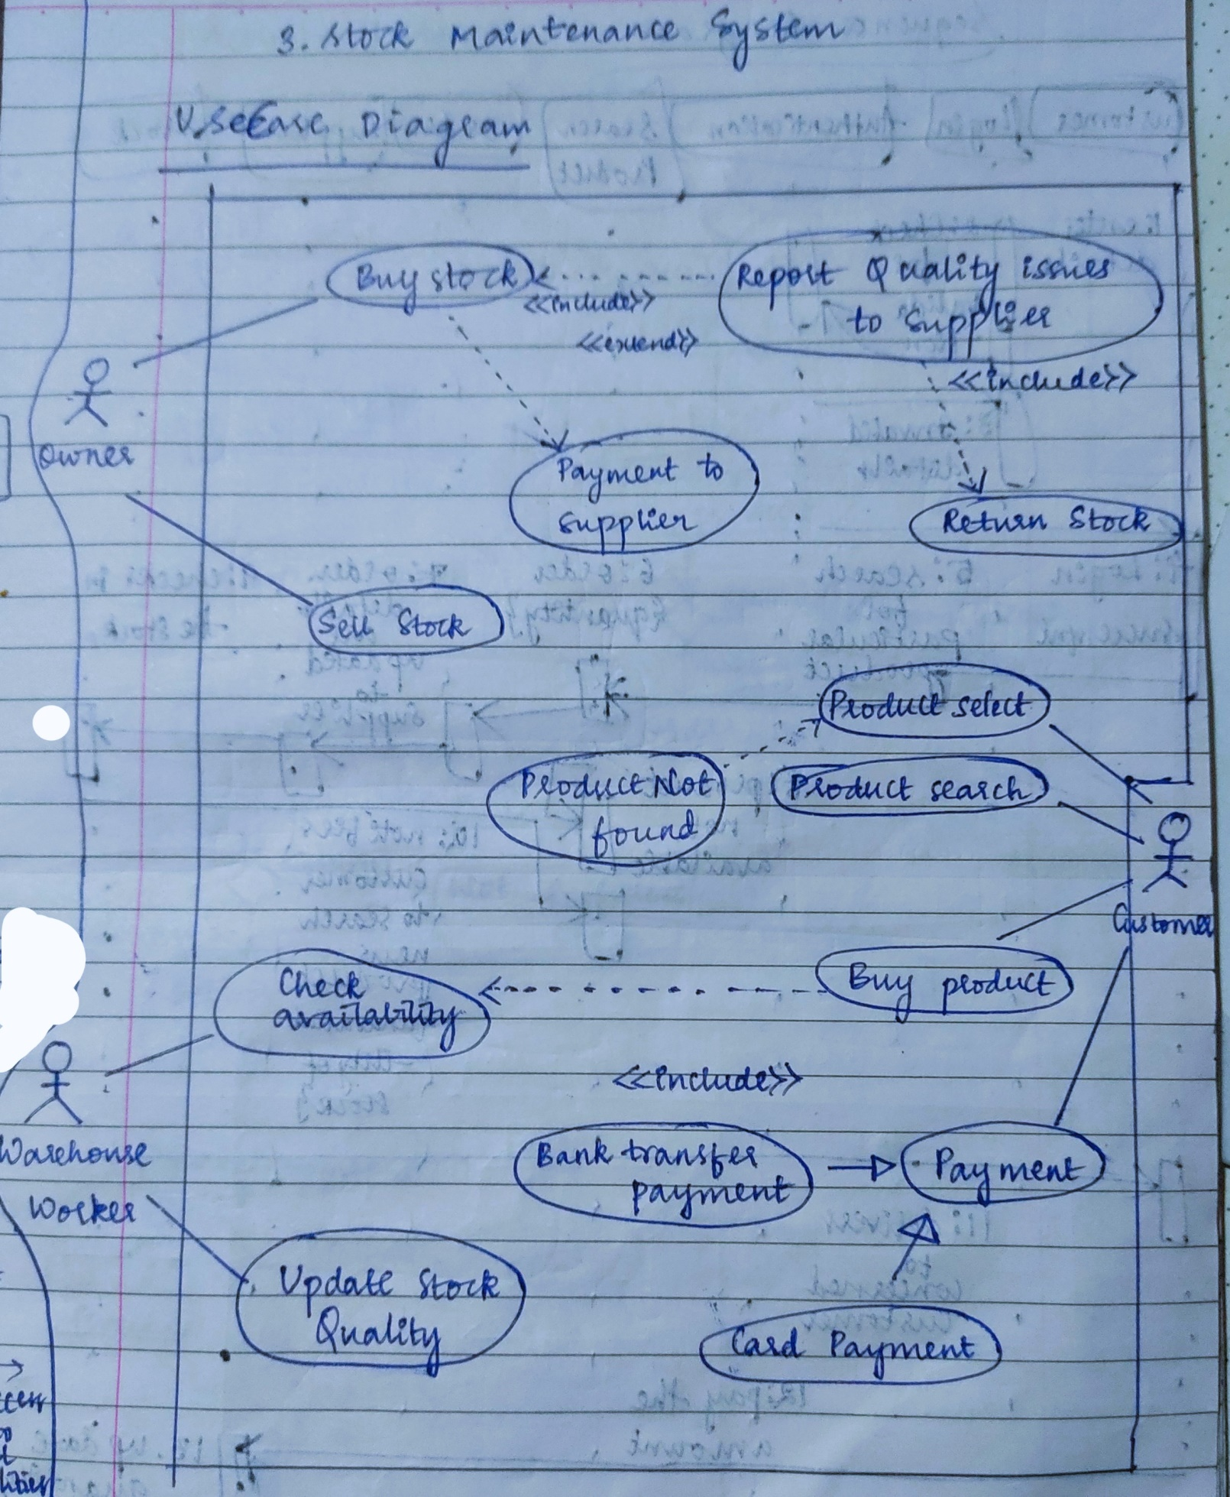

Advanced

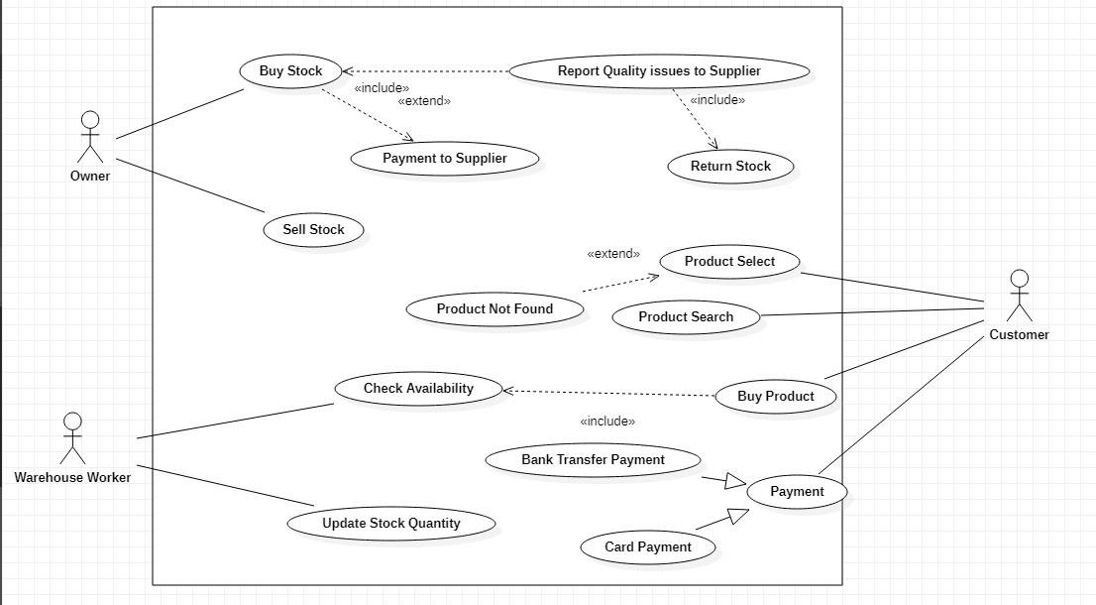

The use case diagram has Owner, Supplier, Customer, Manager as the actors. Each actor is indicated with a use case in the diagram with extend and include advance features.

## Sequence Diagram

Simple

The sequence diagram shows sequence of stock maintenance activities performed by owner, supplier and maintenance of ledger by manager. The owner can order stock from supplier, track order and pay the supplier along with conducting inspection checks.

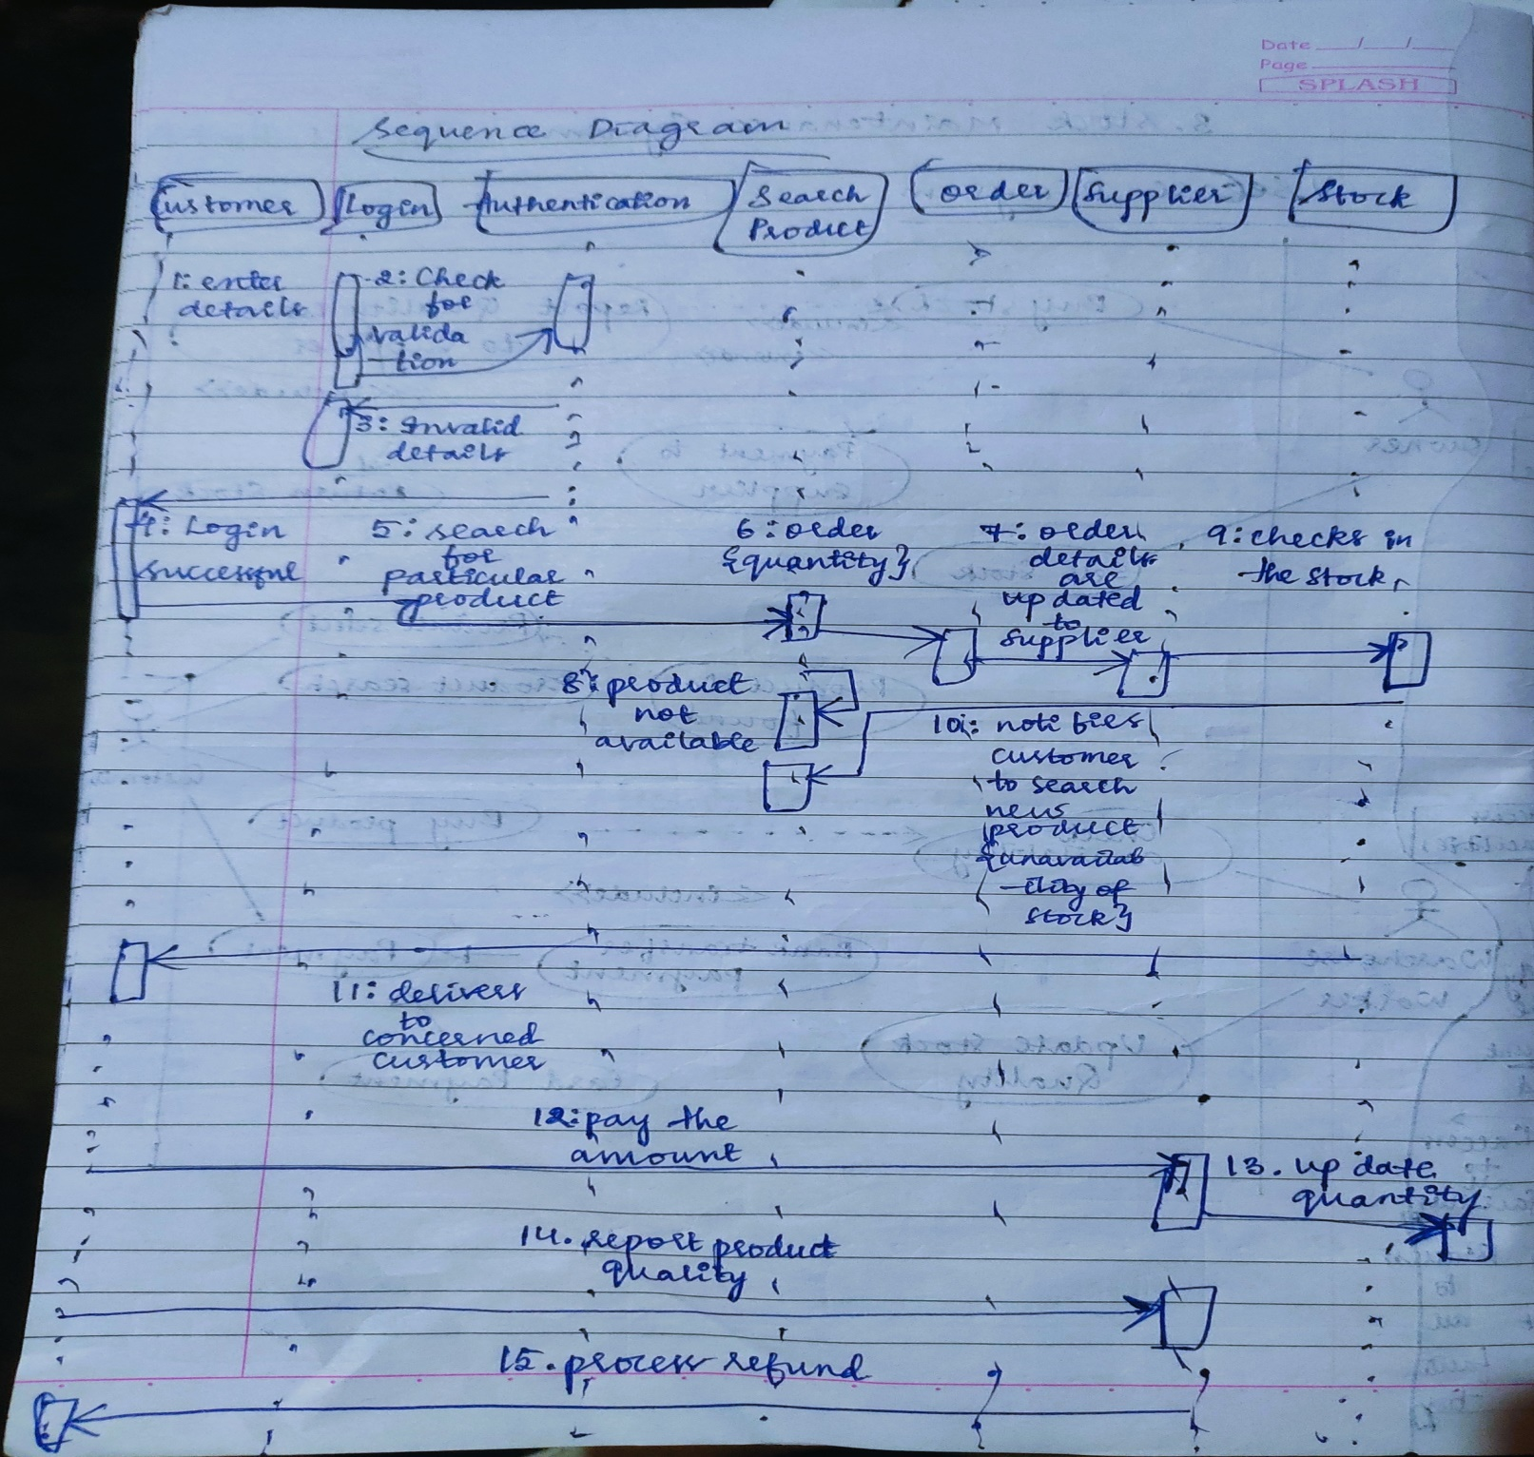

Advanced

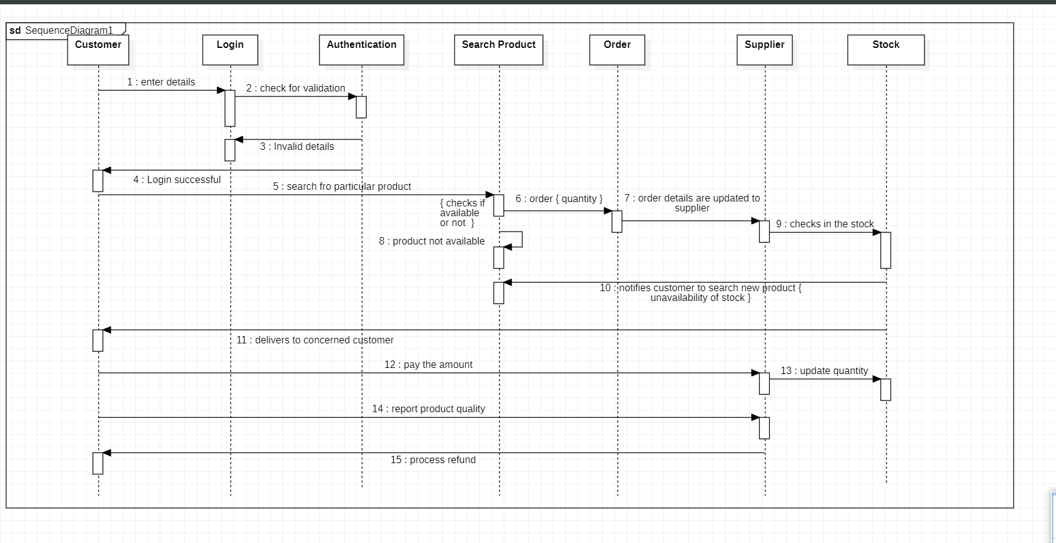

## Activity Diagram

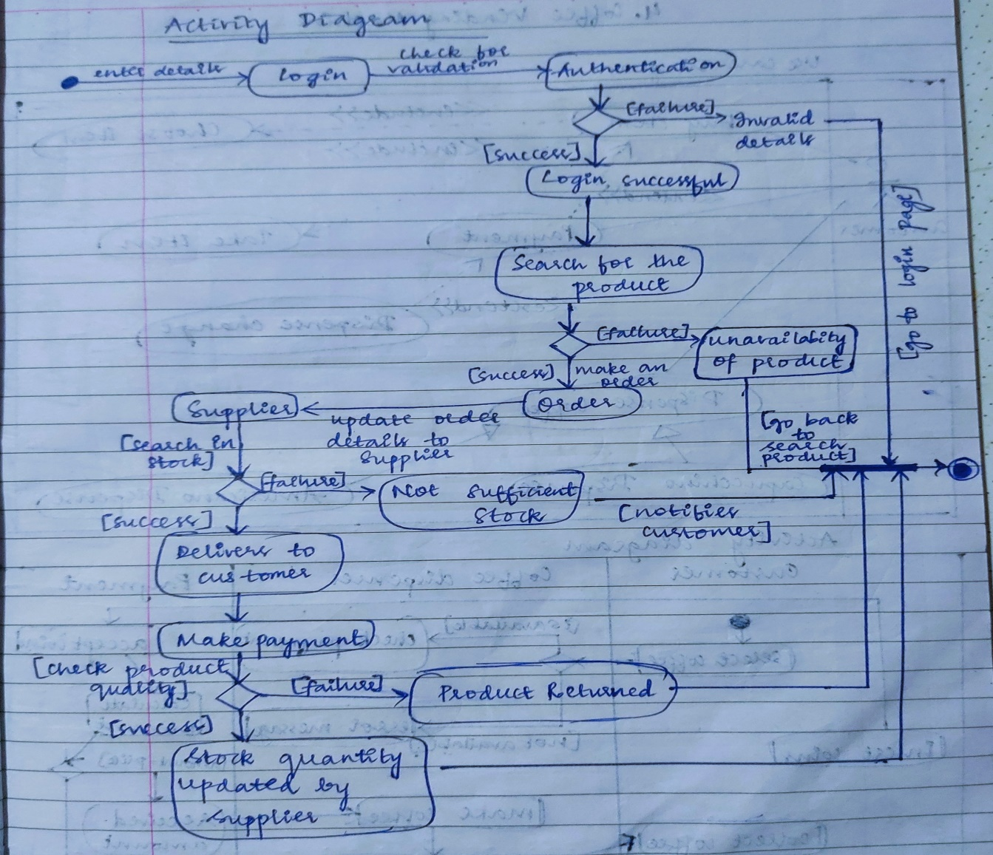

Advanced

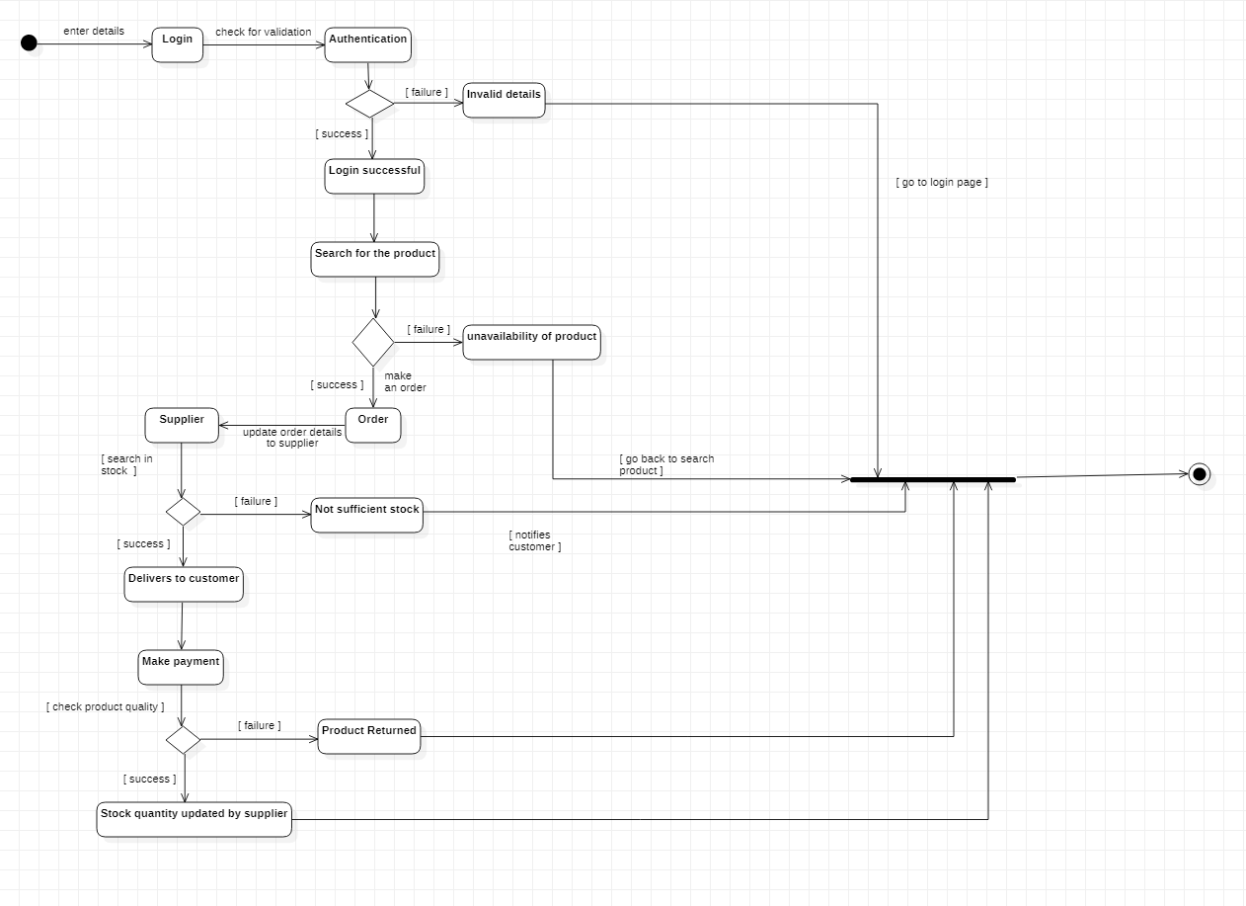

# Coffee Vending Machine

## SRS – Software Requirements Specification

The Objective of the system is to prepare a coffee vending machine for commercial purpose. The system will be able to prepare coffee by processing all its required ingredients. Users will be provided with sophisticated and easy to use user interfaces.

There are many different types of coffee makers using a number of different brewing principles, in the most common devices, coffee grounds are placed in a paper or metal filter inside a funnel, which is set over a glass or ceramic coffee pot, a cooking pot in the kettle family. Cold water is poured into a separate chamber, which is then heated up to the boiling point, and directed into the funnel.

* + 1. Cash Box: Knows amount of money put in; Give change; Knows price of coffee; Turns front panel on and off.
    2. Front panel: Captures selection; Knows what to mix in each; Instructs mixer when to mix.
    3. Mixer: Knows how to talk to the dispensers.
    4. Dispenser [cup-, coffee powder-, sugar-, creamer-, water-]: Knows how to dispense a fixed amount, knows when it is empty.

Features:

1. Small carbon footprint
2. Energy saving advanced power management system
3. Comprehensive drink range
4. Simple user interface
5. One touch servicing

Working: Coffee vending machines are quite simple and basic. The way they work is not too different to how a tabletop coffee machine or even a drip coffee machine operates. If you think about it, making coffee is simply adding together coffee beans or grounds to hot water and mixing with milk and sugar, that's exactly what a hot drink vending machine does.

Functions:

1. Add heat: to heat the coffee we have 3 options. We could use a heating element where the water gravity fed into a tubular heating element, external to the water reservoir, and boiled out. Secondly, we could use a submersible heating element placed inside of the water reservoir to heat all of the water at once. Thirdly, we could use an external hot plate to heat one or multiple walls of the water reservoir and thus heat the water through surface convection.
2. Direct Water: The fluids could be directed from the water reservoir to their final destination via tubing, gravity reed, and pump.
3. Contain Water/Coffee: To contain the water and coffee we could use one reservoir, two reservoirs or a funnel. If one reservoir was used for both the water and coffee container, our design would be French press coffeemaker.
4. Reduce Noise: To reduce the overall noise we consider two options: noise dampening material and internal brew mechanism. To lessen the noise produced by our designs we could fill or cover the outer shell of a noise dampening material. We could also keep the brew mechanism, whether it is drip spout.

Maintenance: When it comes to the ways in which coffee vending machines work, it’s not all about the coffee, it’s also about the upkeep and maintenance of the machine. With regular visits, suppliers should empty the cash drawer, reconcile the proceeds against sales, empty the waste grounds, refill ingredients and cups, and generally undertake any

work to both the interior and exterior to keep everything running smoothly, such as ensuring there’s no buildup of dirt around the exterior buttons that could cause them to stick, and making sure nothing is blocking the internal sensors that could prevent some ingredients from being added to the mixing chamber

## Class Diagram

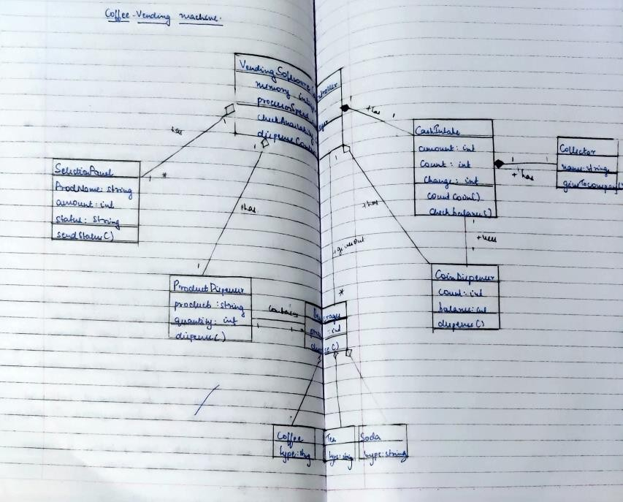

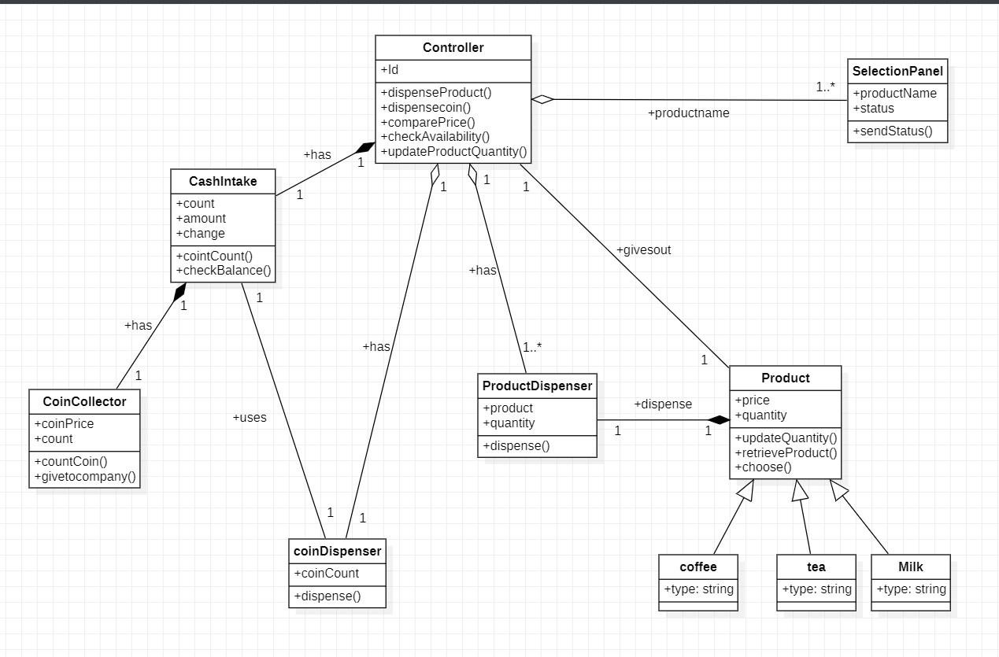

## State Diagram

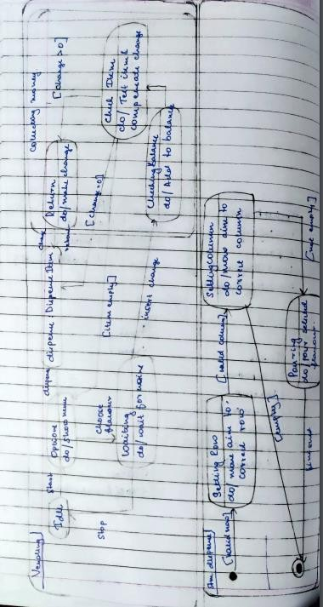

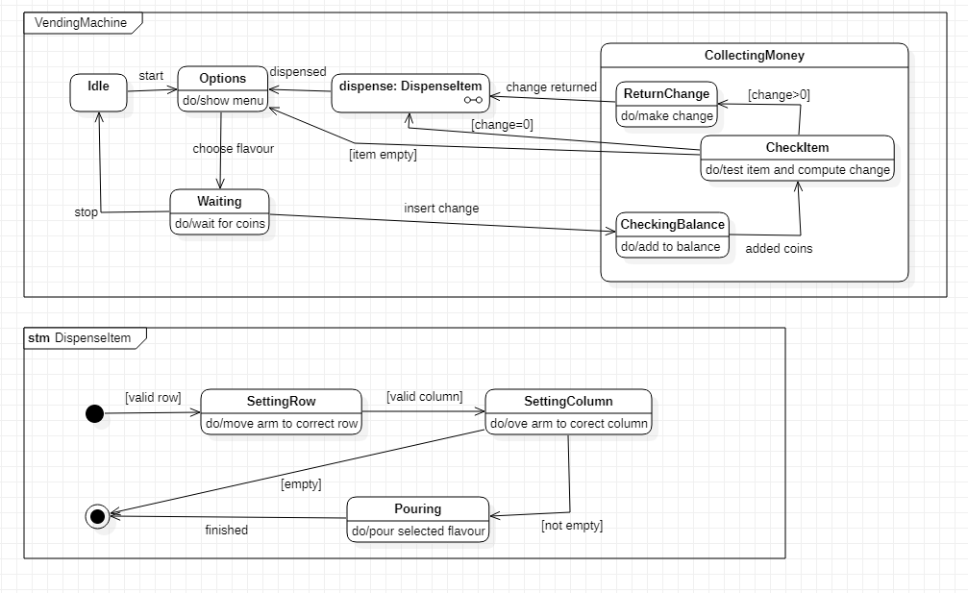

The above scenario includes displaying the item, selecting it, checking availability, inserting coins, computing change and dispensing item.

## Use Case Diagram

Simple

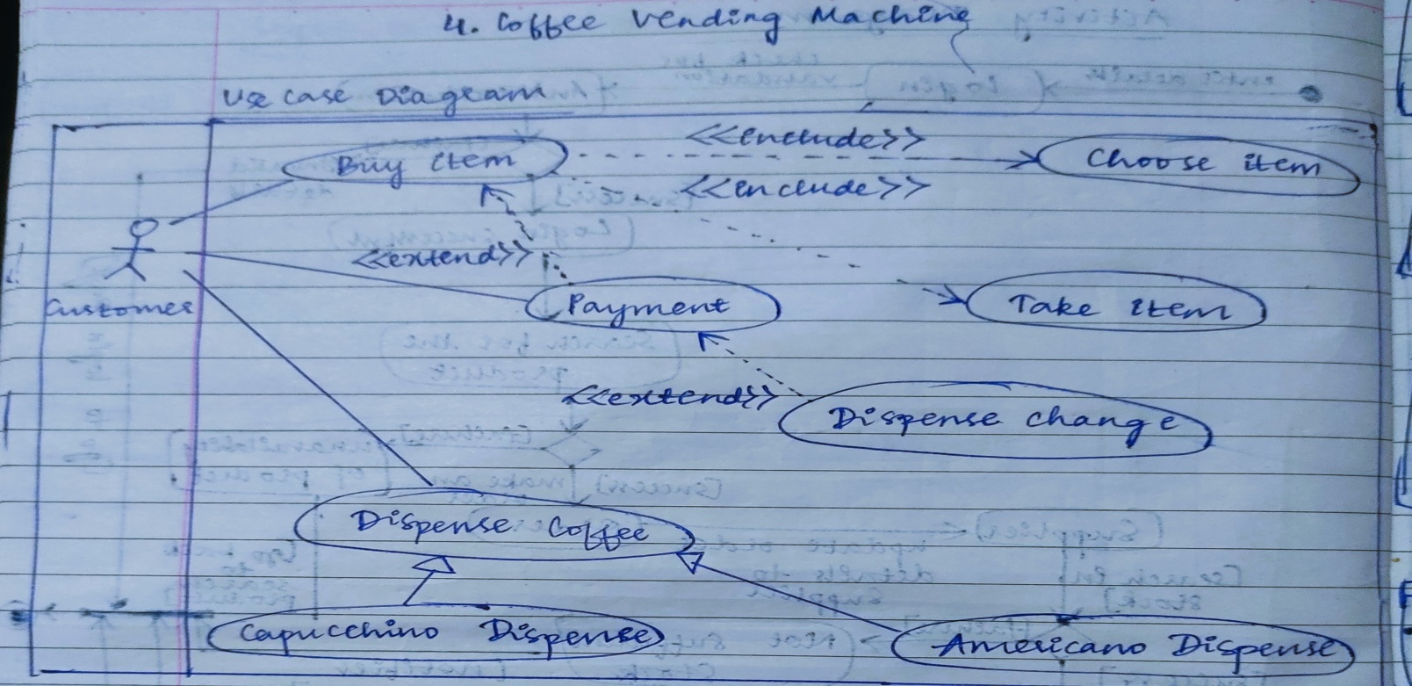

Advanced

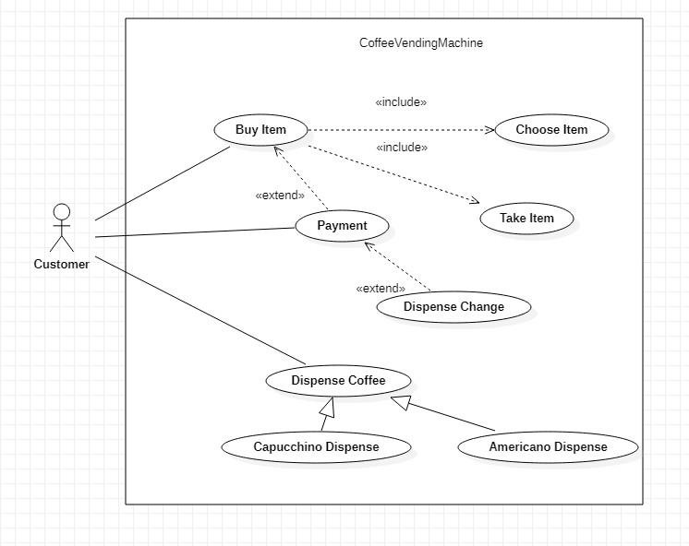

* Sequence Diagram

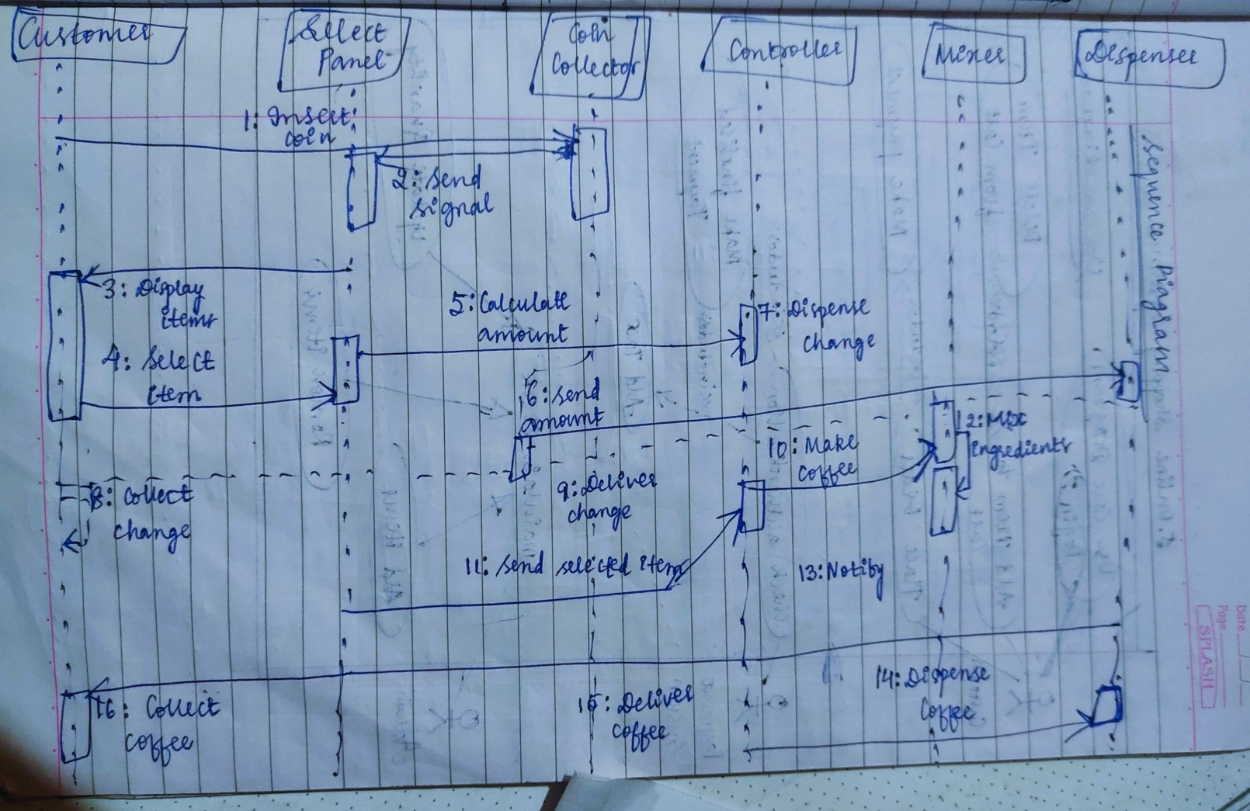

Advanced

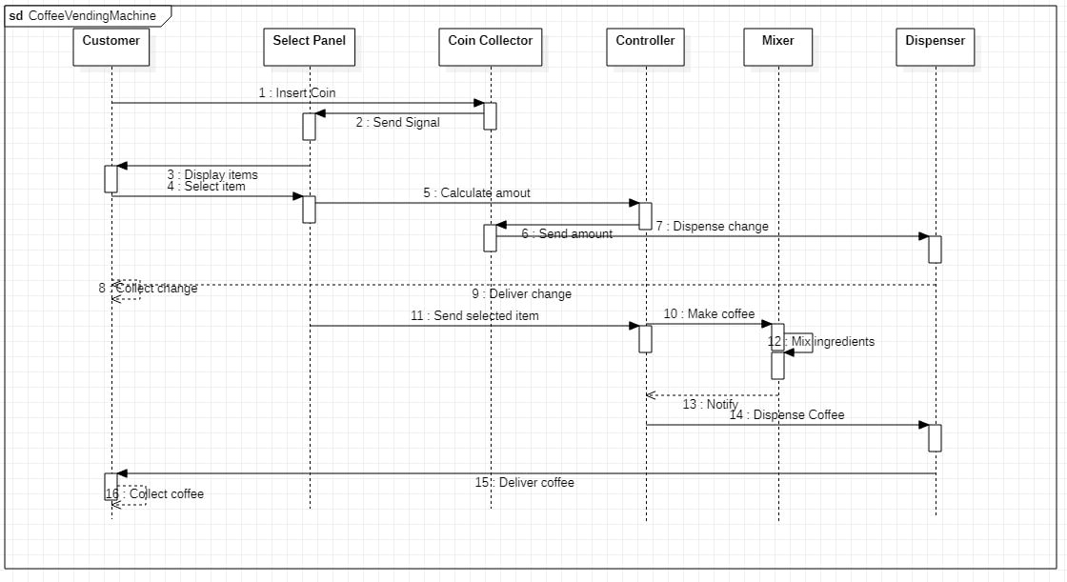

The above scenario includes displaying the item, selecting it, checking availability, inserting coins, computing change and dispensing item.

## Activity Diagram

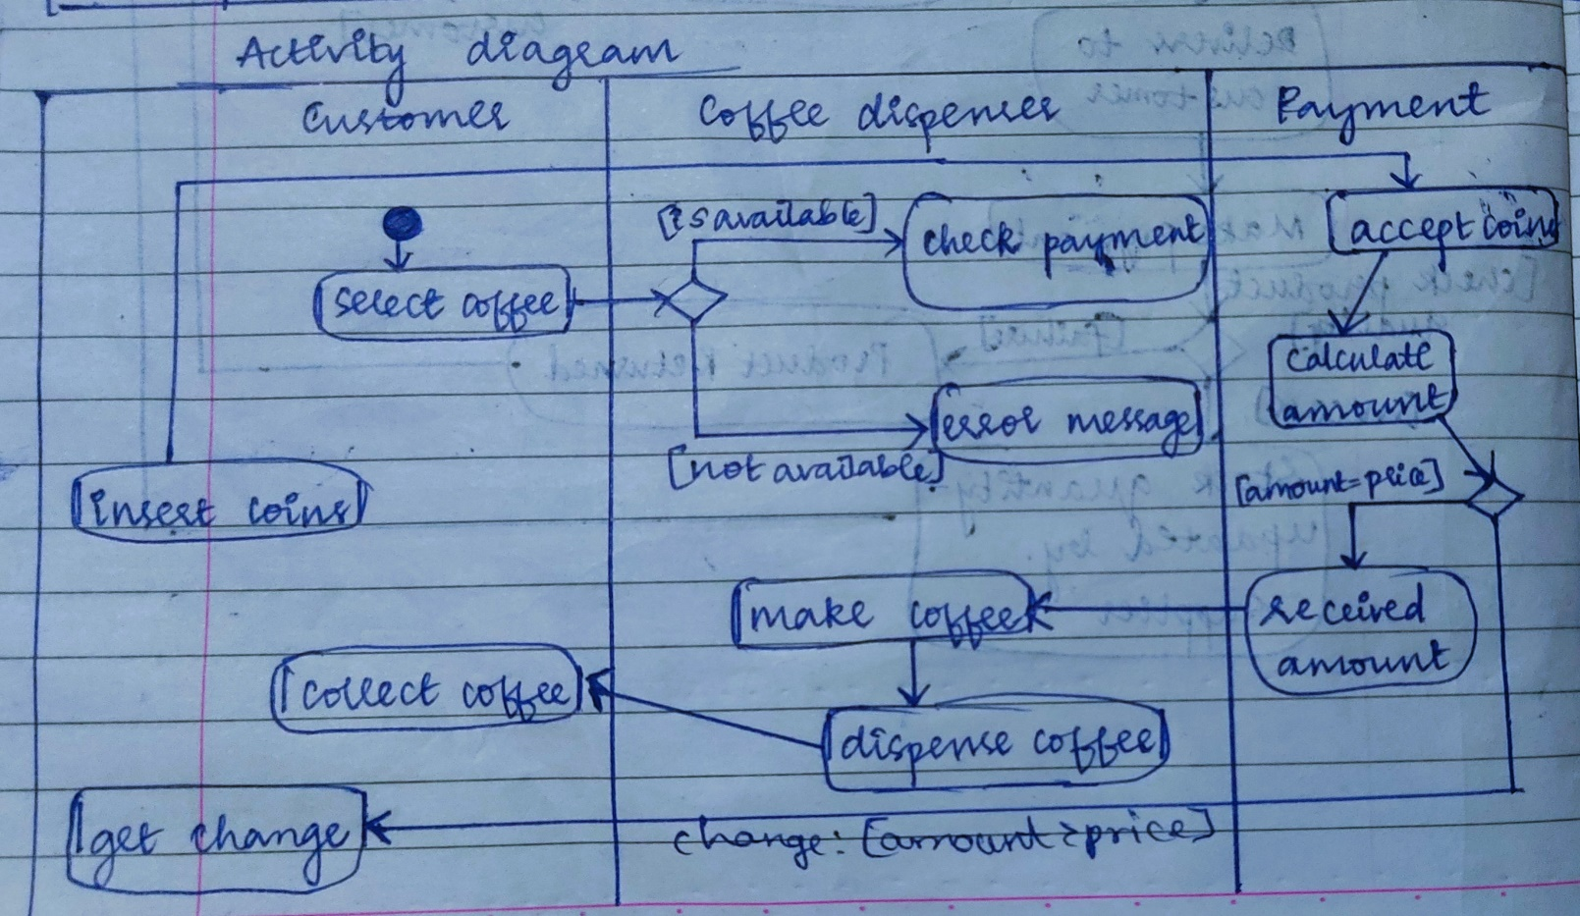

Advanced

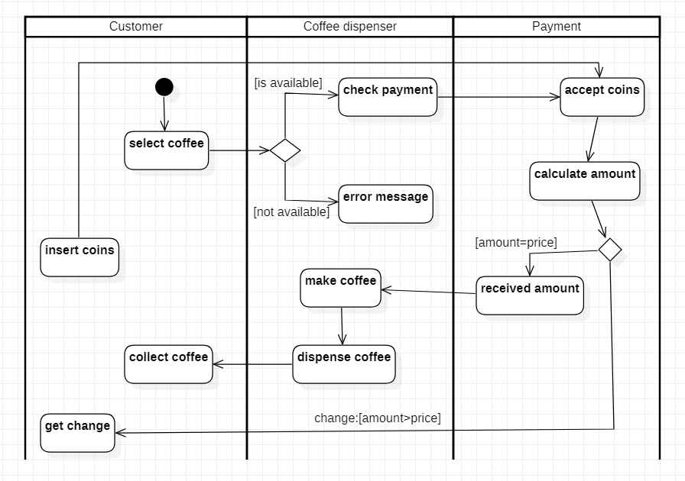

# Online Shopping System

## SRS – Software Requirements Specification

The online shopping system allows the users and vendors to exchange products remotely and reduces the amount of cost and time substantially.

The software provides the following facilities to the customers:

1. Facilitates easy shopping online anywhere with free shipping (conditions apply).
2. Provides information about the products in categories
3. Can avail the facility of purchasing second hand products
4. Can reserve if the particular product is not available
5. Customers are provided with up-to date information on the products available
6. Provides email facility for future correspondence
7. Provides backup facility
8. Can add nearly ten products to their shopping cart at a time.

The software will not provide the following facilities to the customers:

1. Cannot reserve the product for more than two days.
2. Cannot reserve more than two products
3. Responsibility of damages
4. The product cannot be changeable once confirmed

The software provides the following facilities to the merchants:

1. Facilitates easy bidding facility
2. Provides complete information about the customers
3. Provides complete information about their products
4. Can avail the facility of email correspondence
5. Can avail the brand catalog facility.

## Class Diagram

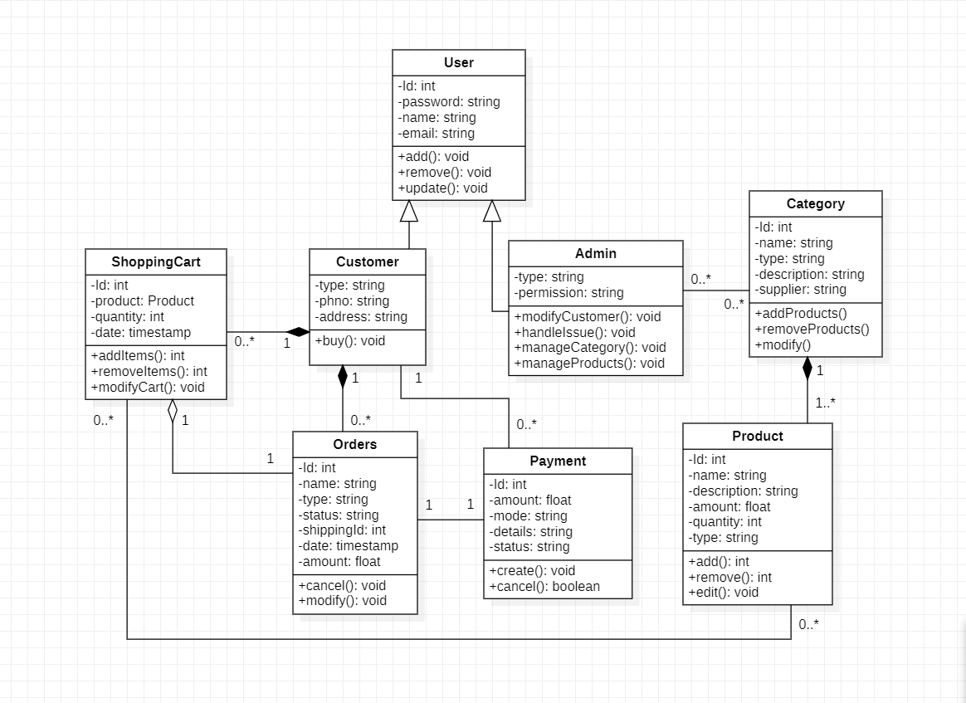

* State Diagram

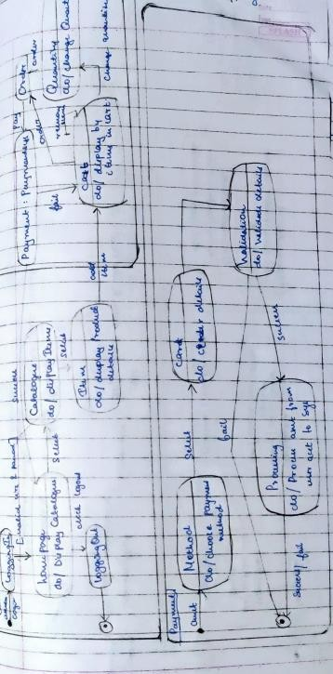

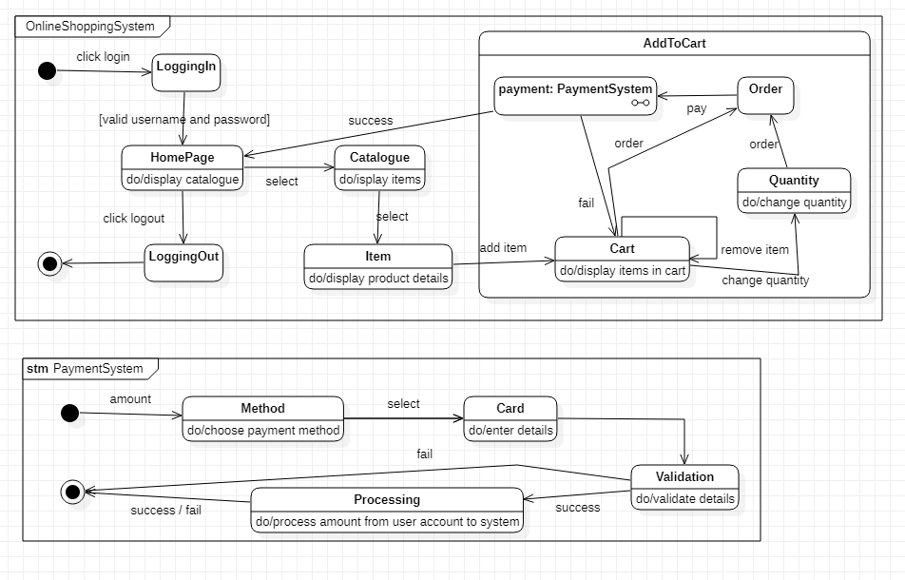

This includes logging in, selecting item, checking availability, adding to cart, payment and confirmation.

## Use Case Diagram

Simple

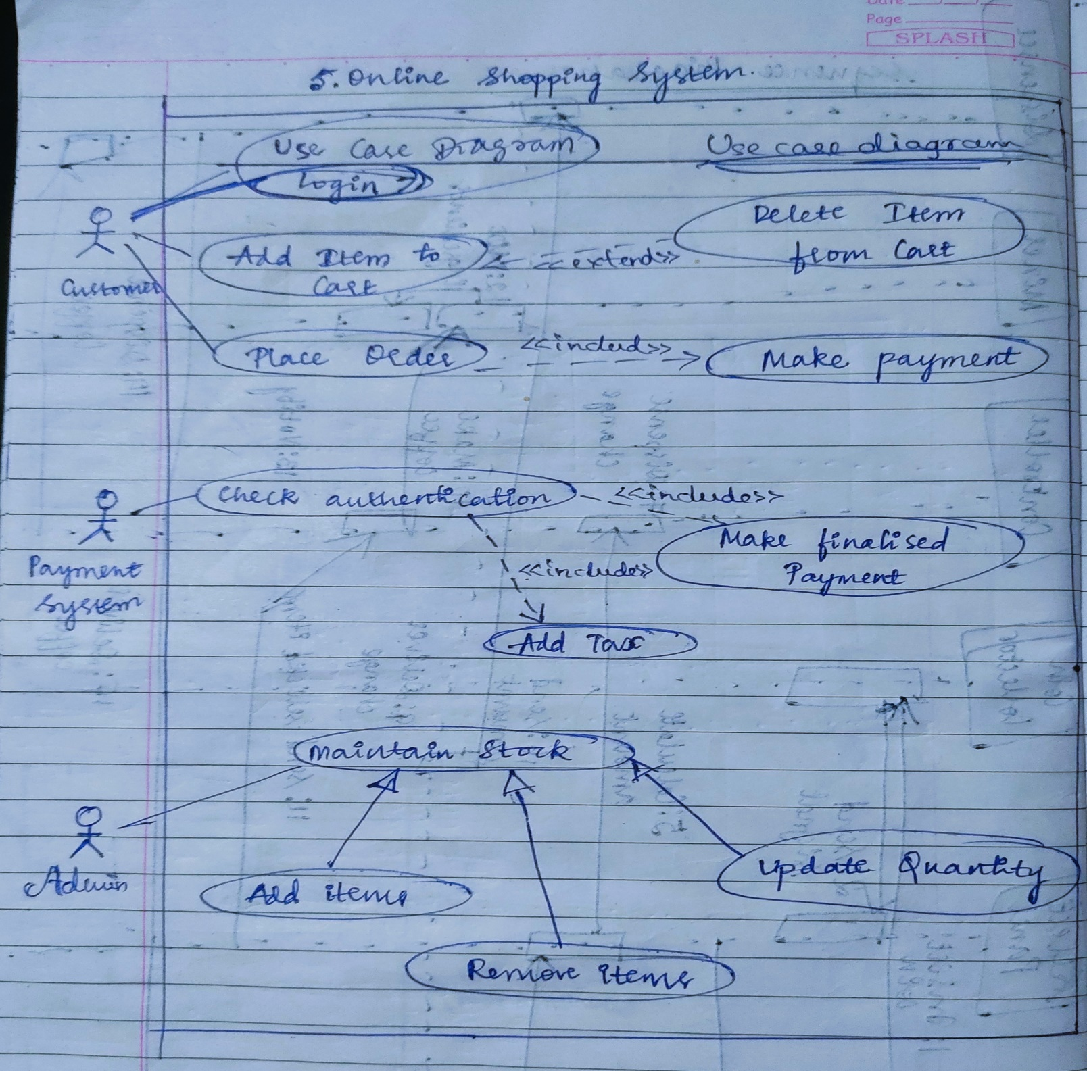

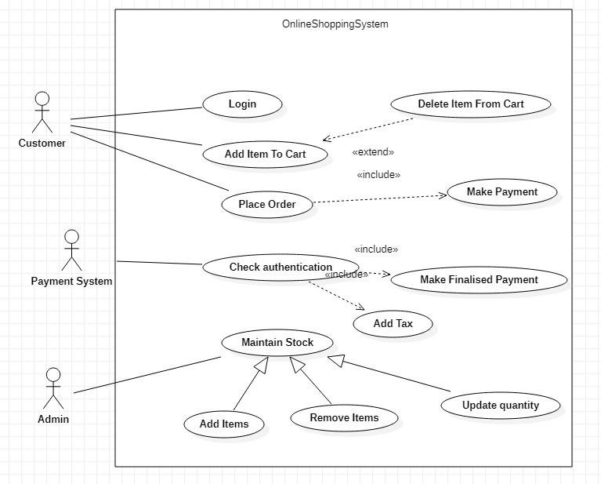

This includes logging in, selecting item, checking availability, adding to cart, payment and confirmation.

## Sequence Diagram

Simple

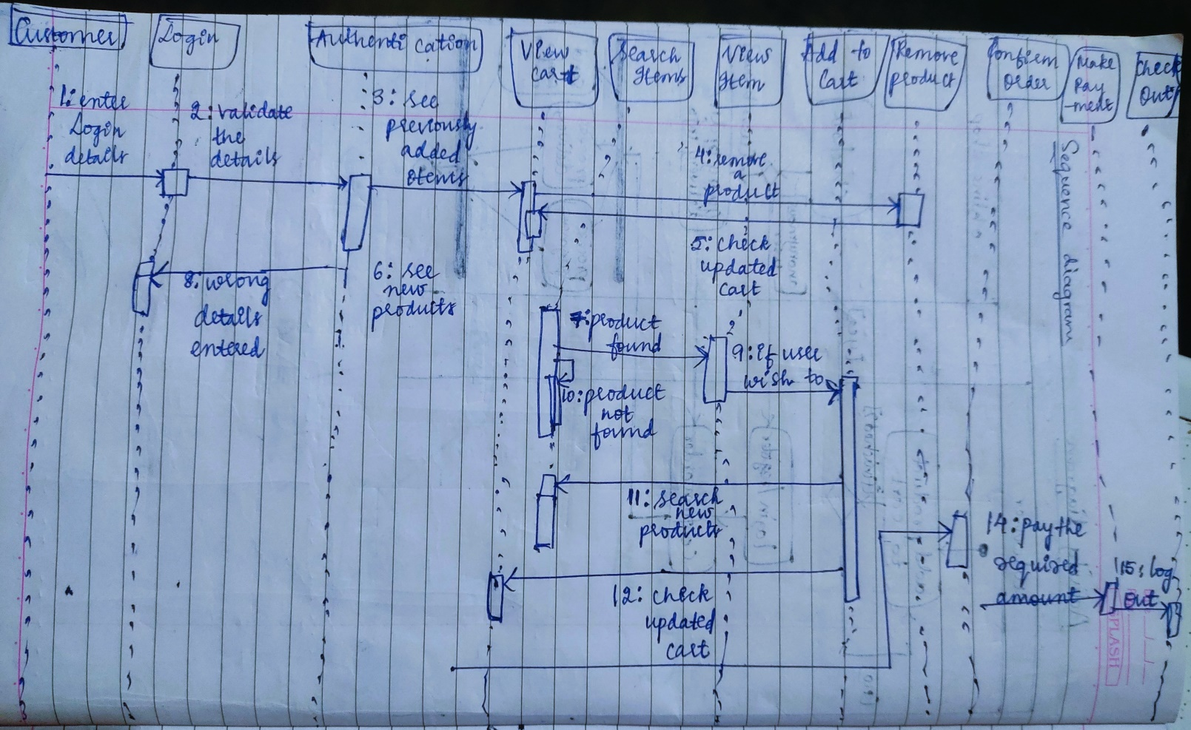

Advanced

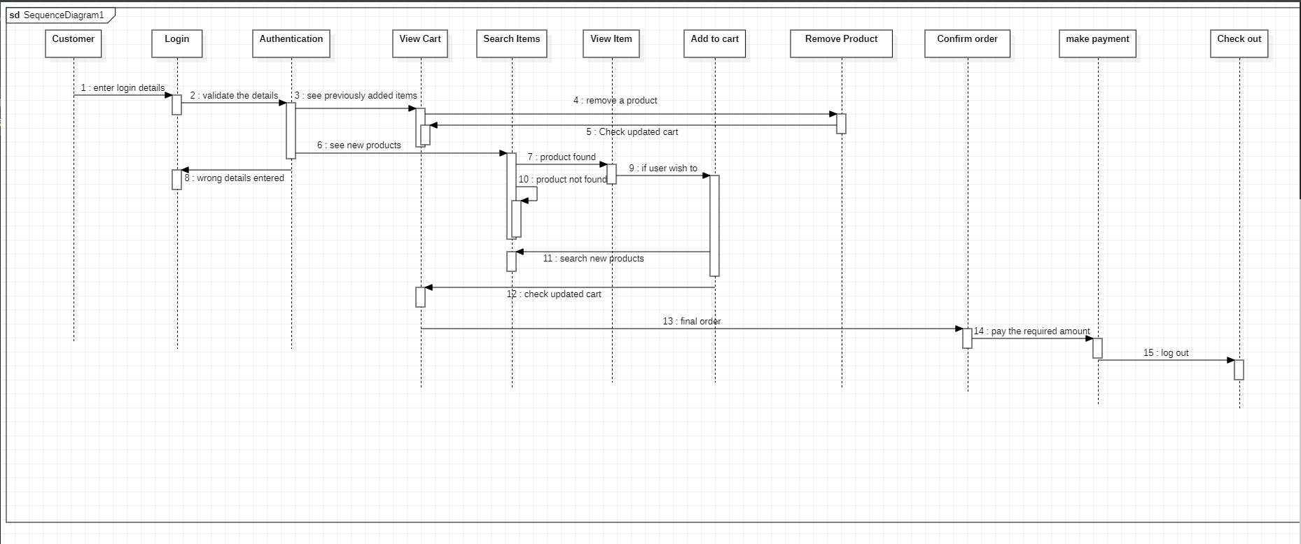

This includes logging in, selecting item, checking availability, adding to cart, payment and confirmation.

## Activity Diagram

Simple

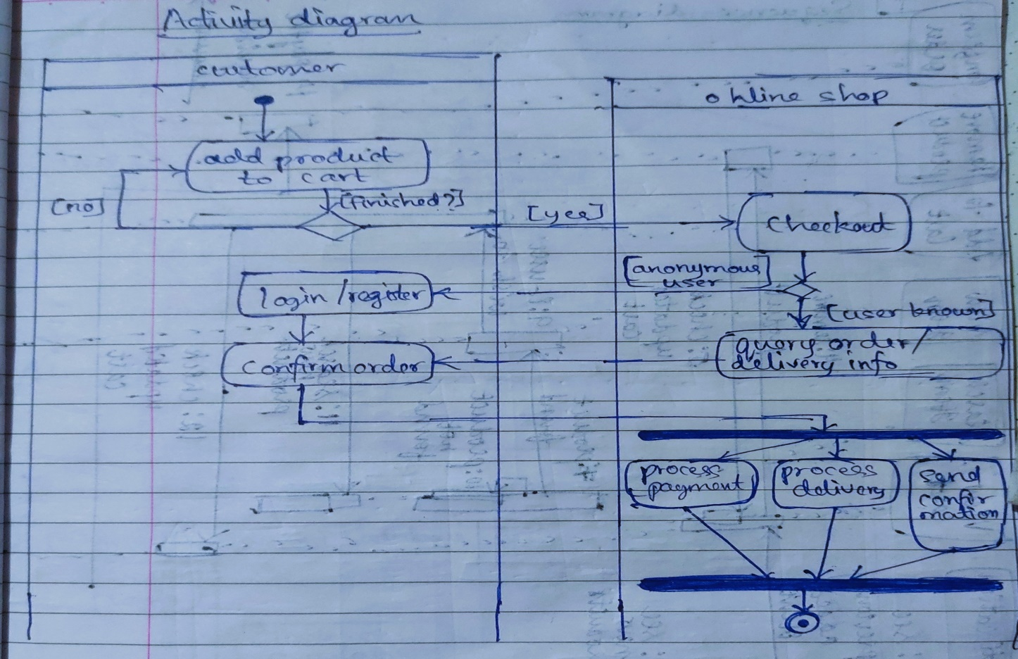

Advanced

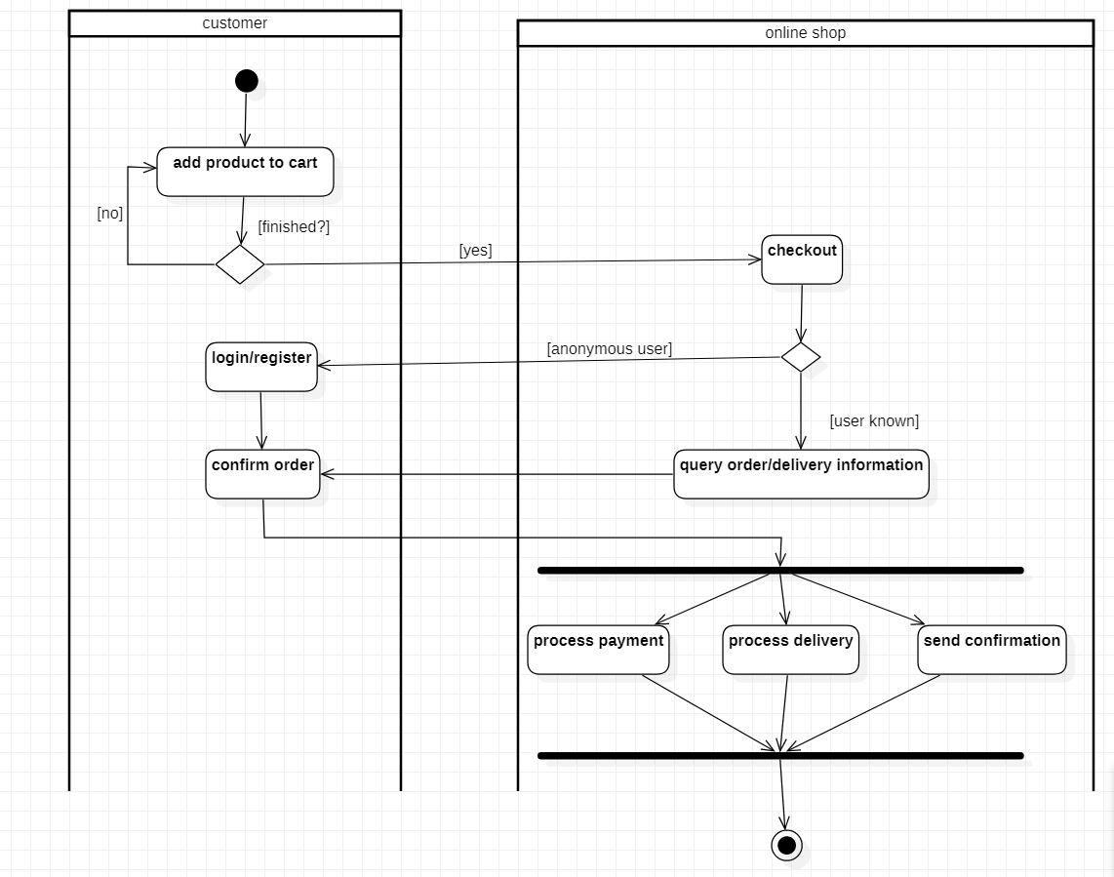

# Railway Management System

## SRS – Software Requirements Specification

To develop a user-friendly Railway Reservation System to enable passengers to book tickets online and make payment online as well.

Railway reservation system project which provides the train timing details, reservation, billing and cancellation on various types of reservation namely,

* + - Confirm Reservation for Seat.
    - Reservation against Cancellation.
    - Waiting list Reservation.
    - Online Reservation.
    - Tatkal Reservation

This system enables the Advance booking in any class, against general and ladies-quota, on payment of fare in full for adults and children, a maximum of six berths/seats at a time, for journey between any two stations served by a train.

It also provides details about

1. Timetable
2. Train Fares
3. Current status of reservation position
4. Train available between a pair of stations
5. Accommodation available for a train/date combination Types of tickets: General and Tatkal.

## Class Diagram

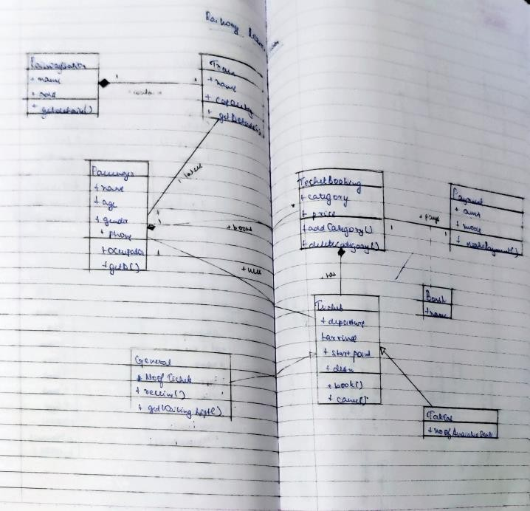

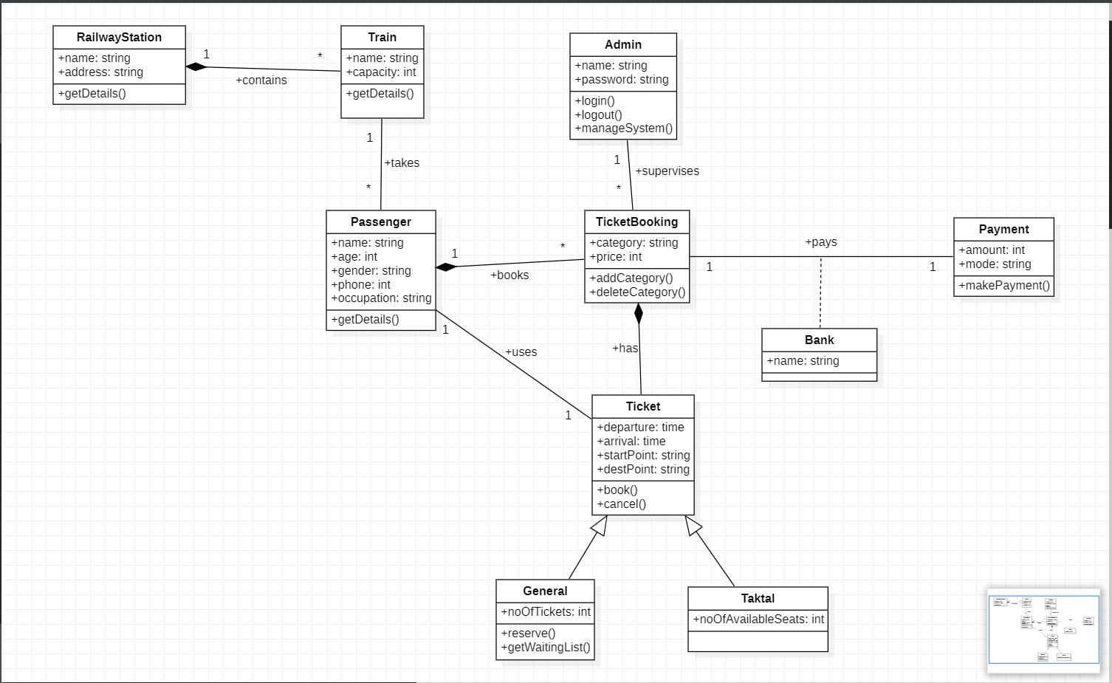

* + State Diagram



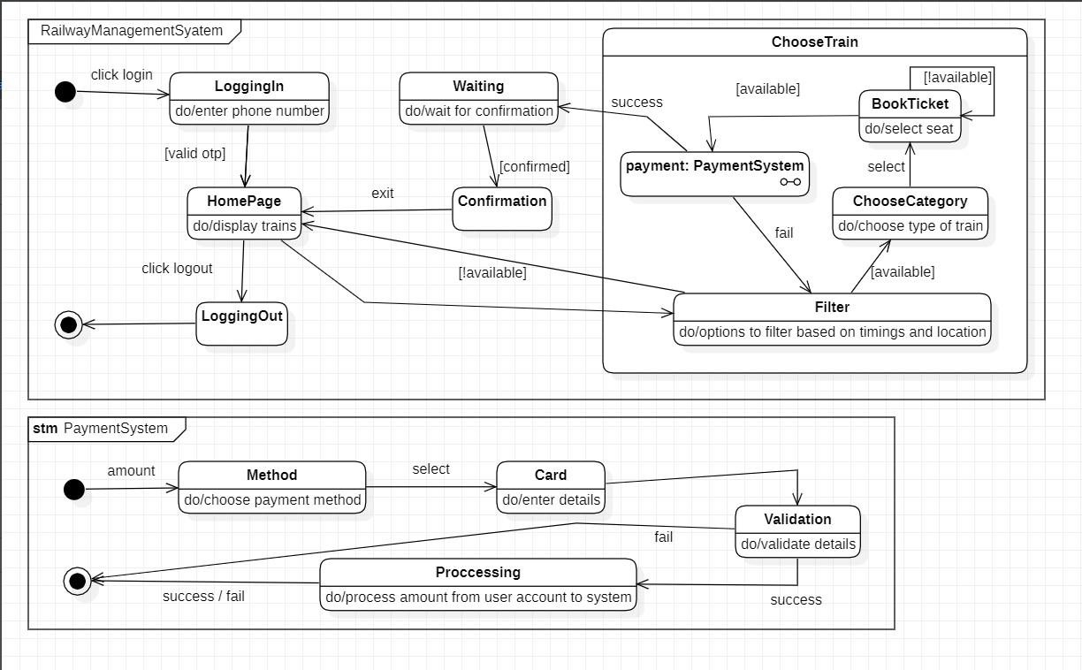

This includes checking the availability, booking, filling form, payment and confirmation.

## Use Case Diagram

Simple

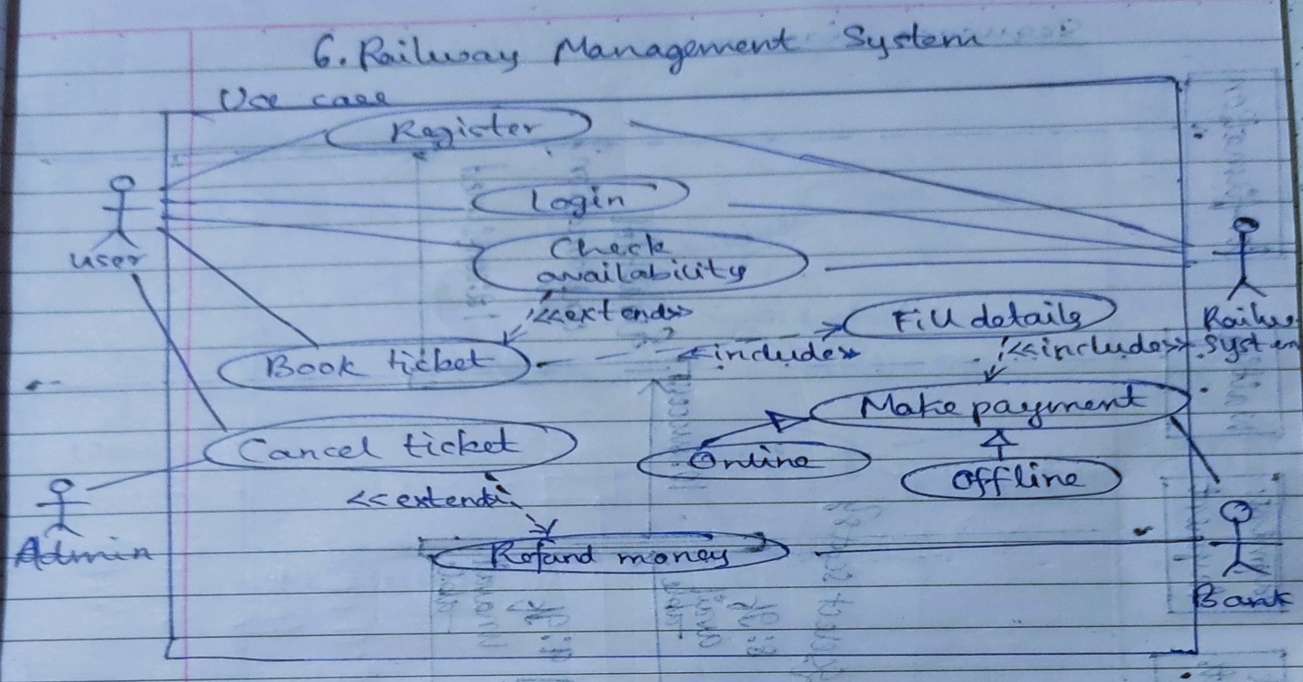

Advanced

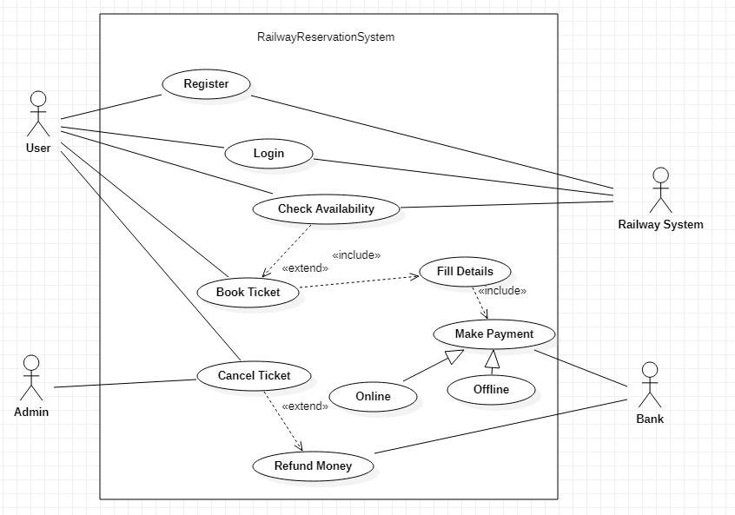

## Sequence Diagram

Simple

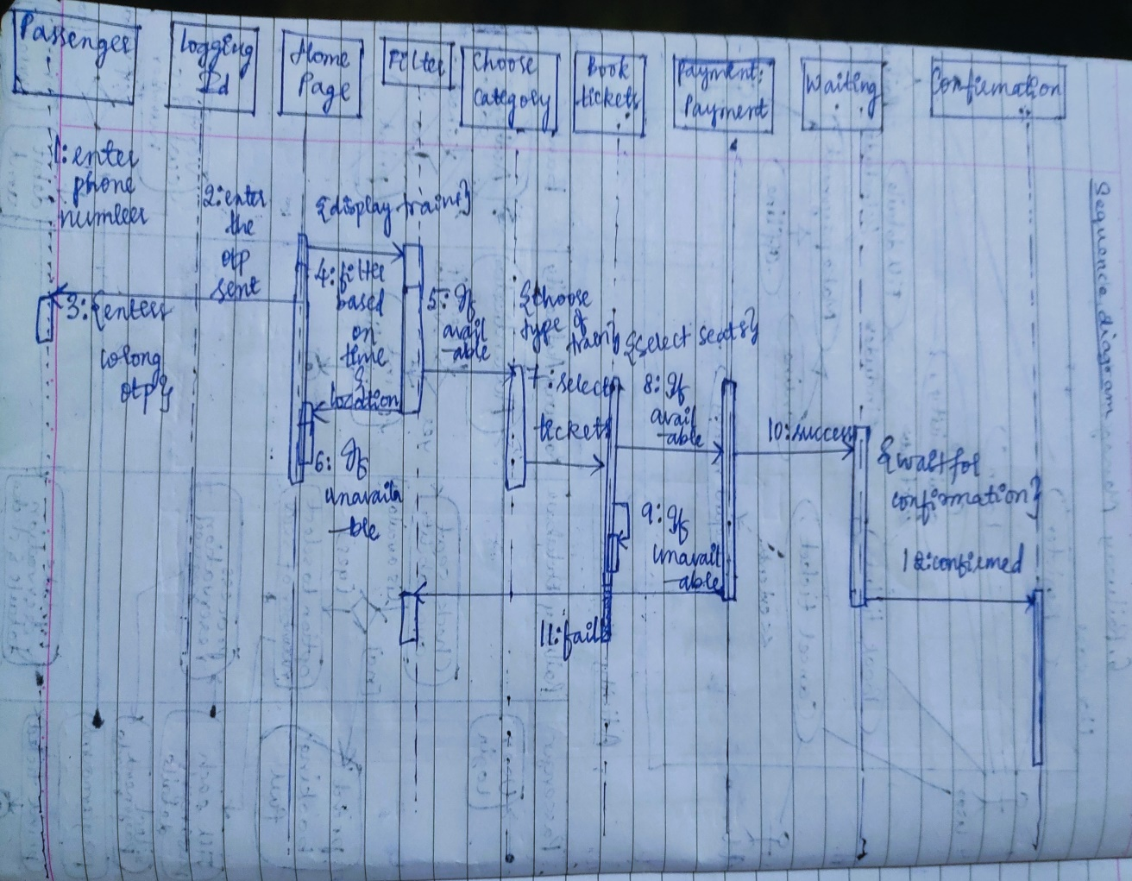

Advanced

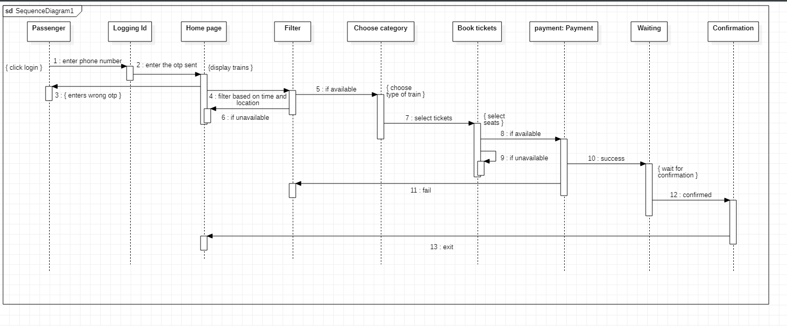

## Activity Diagram Simple

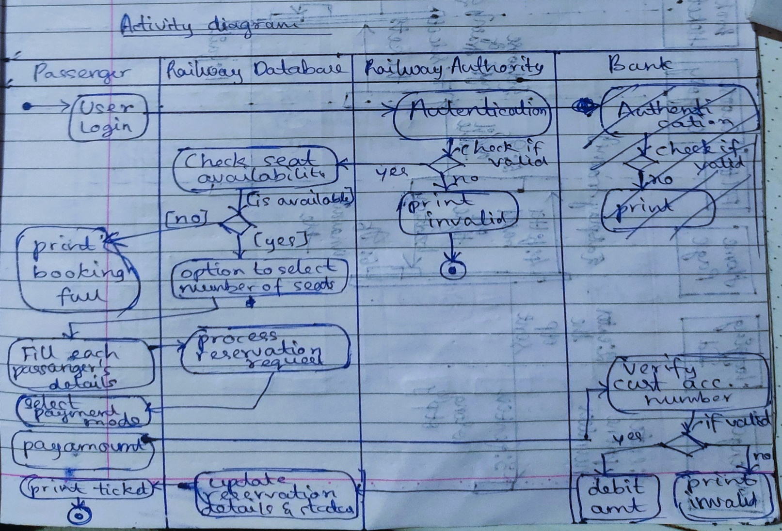

Advanced

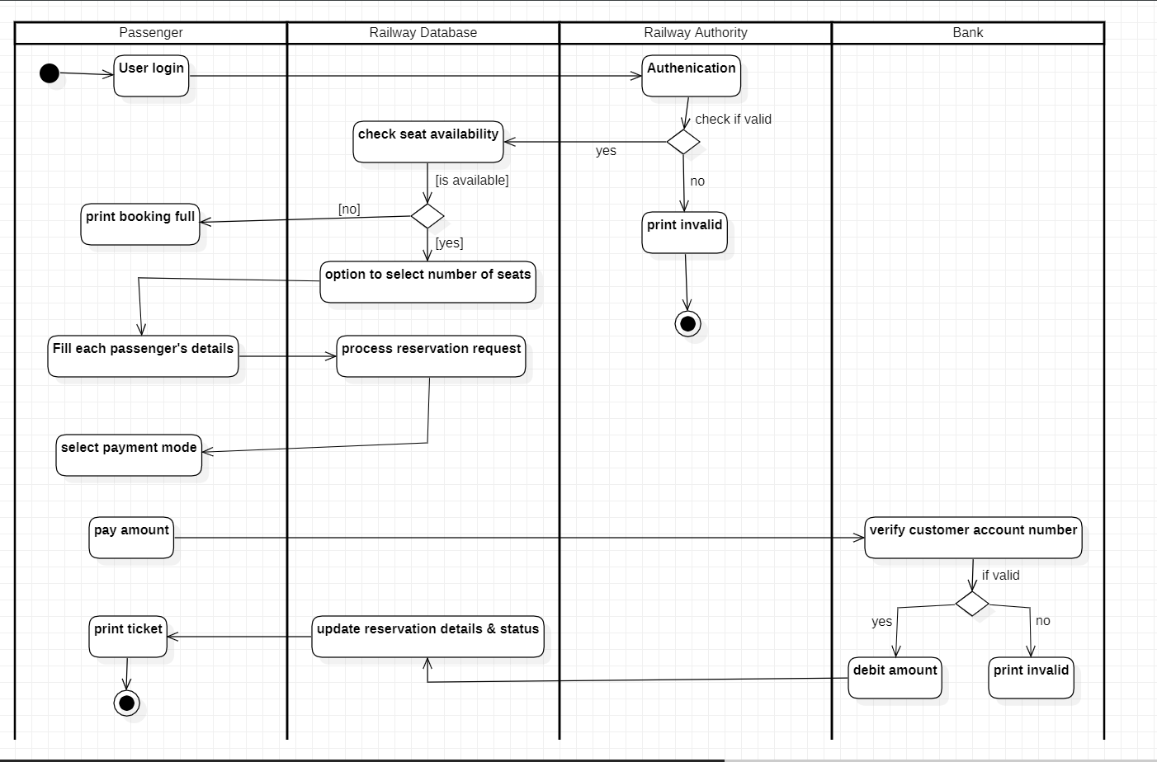

This includes checking the availability, booking, filling form, payment and confirmation.

# 7. Graphics Editor System

## SRS – Software Requirements Specification

The graphics editor provides an Application Programmer’s Interface that enables a programmer to develop their own graphical model editor for a specific type of model. This API in turn, relies on extending the Eclipse Graphical Editing Framework to provide an environment in which the editor functions, and the programmer can create a graphical editor and palette of shapes in order to modify an underlying model. The graphical editor provides an interface with which the programmer implements said editor for a given underlying model. Such an instance of the graphical editor allows a user to drag objects from a specified model into a working graphical diagram.

It should support following functionalities:

* + - It contains the toolbox which contains tools like: Line, Circle, Rectangle, Arc, Text, Draw, Eraser
    - Color box or palette
    - Standard toolbar with options for New, Open, Save, toolbox and Text Toolbox.
    - One integrated view to users for toolbar, color box, menu, and graphic screen.
    - Easy handling of tools for users.
    - Ability to group several drawings into one i.e., complex drawing.
    - Provision of zoom in and zoom out.
    - Different shadings of line tool are provided.

## Class Diagram

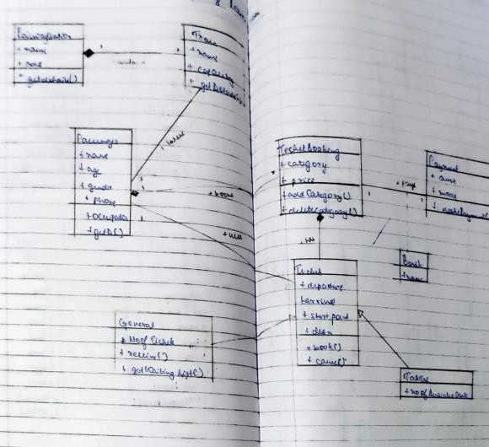

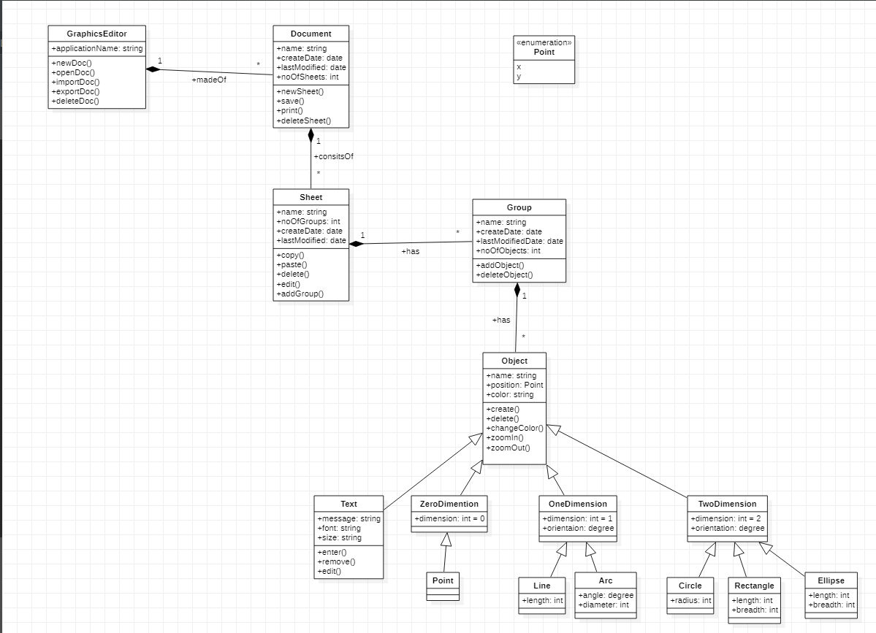

This includes checking the availability, booking, filling form, payment and confirmation.

State Diagram

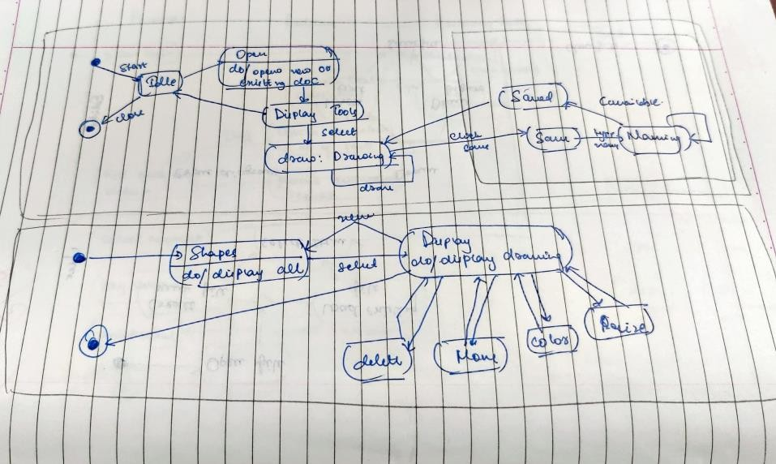

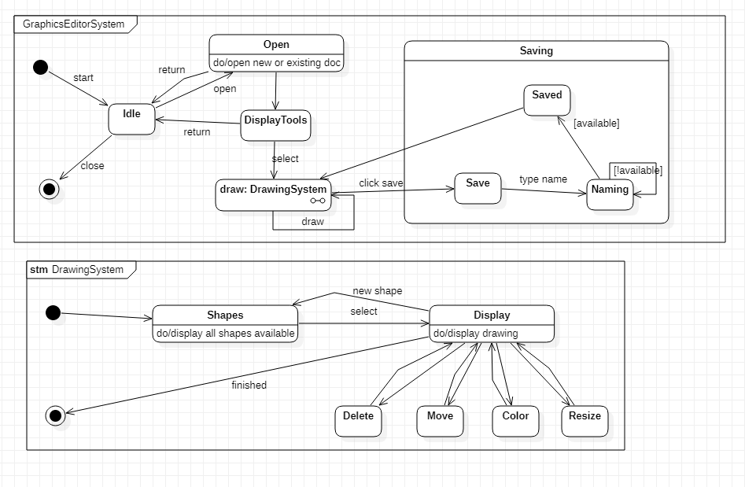

This includes checking the availability, booking, filling form, payment and confirmation.

## Use Case Diagram Simple

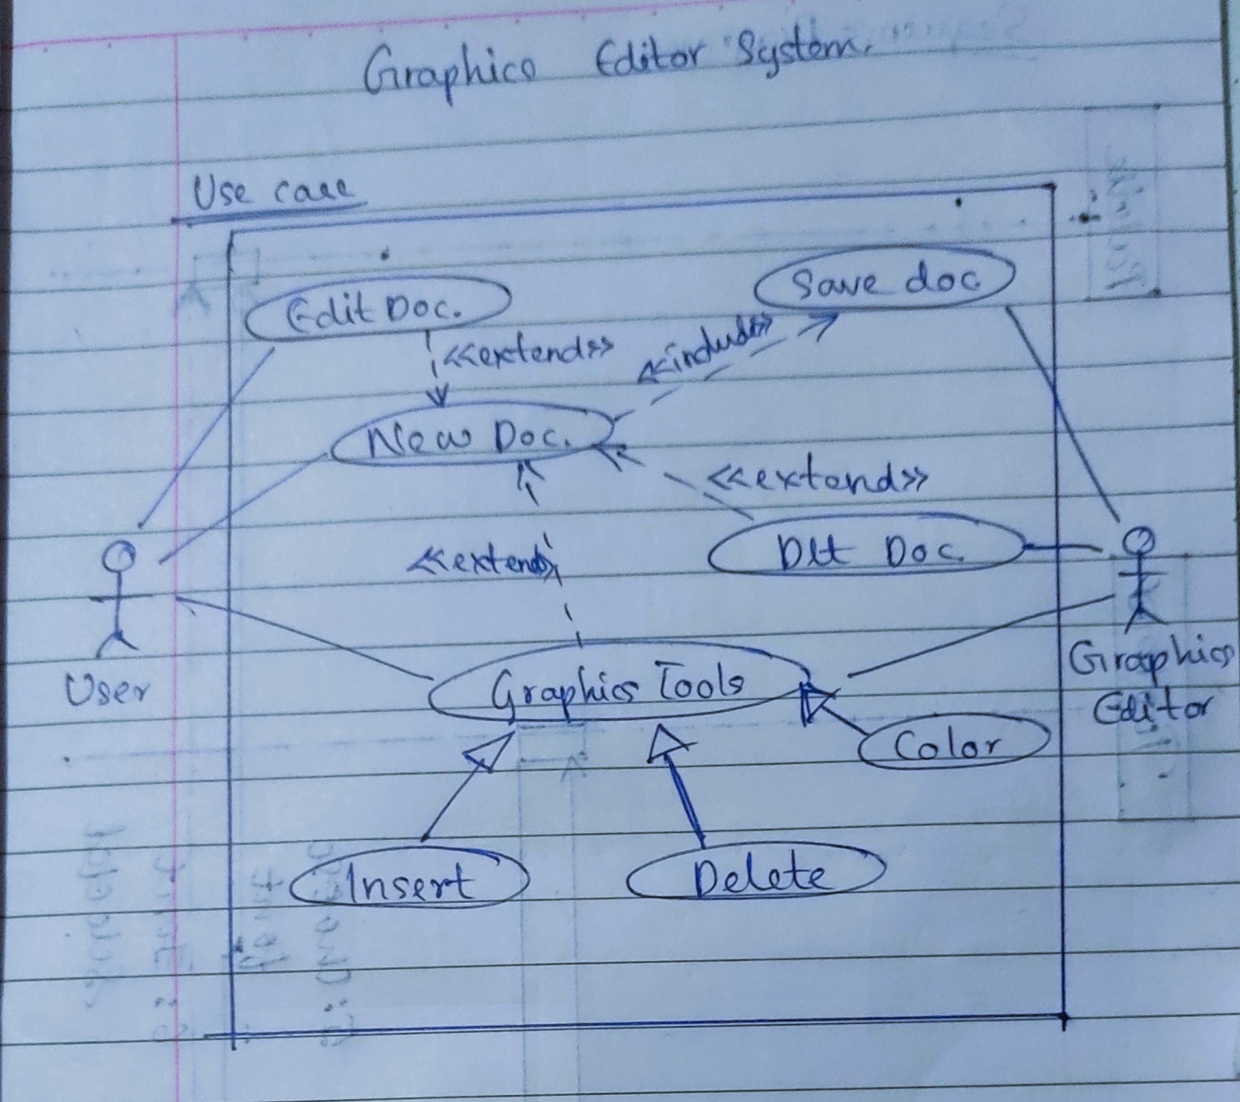

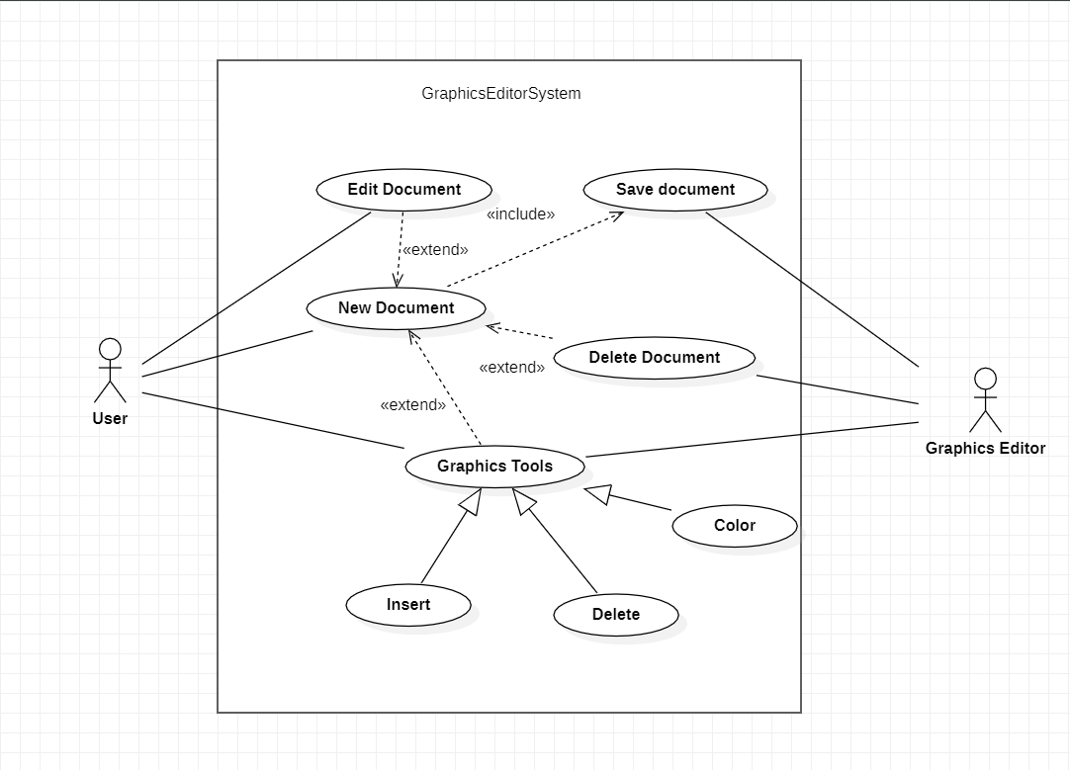

This includes checking the availability, booking, filling form, payment and confirmation.

## Sequence Diagram

Simple

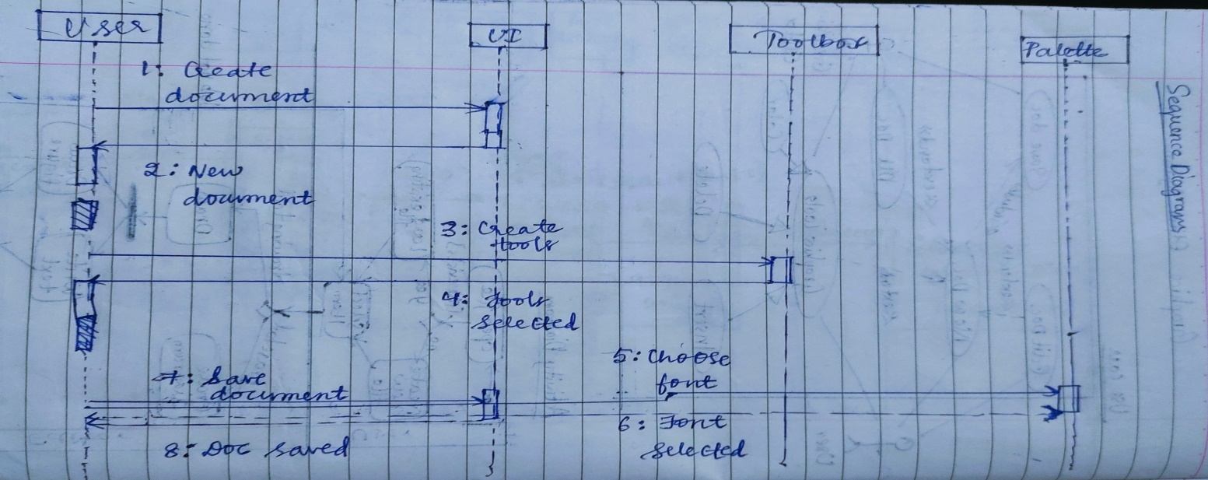

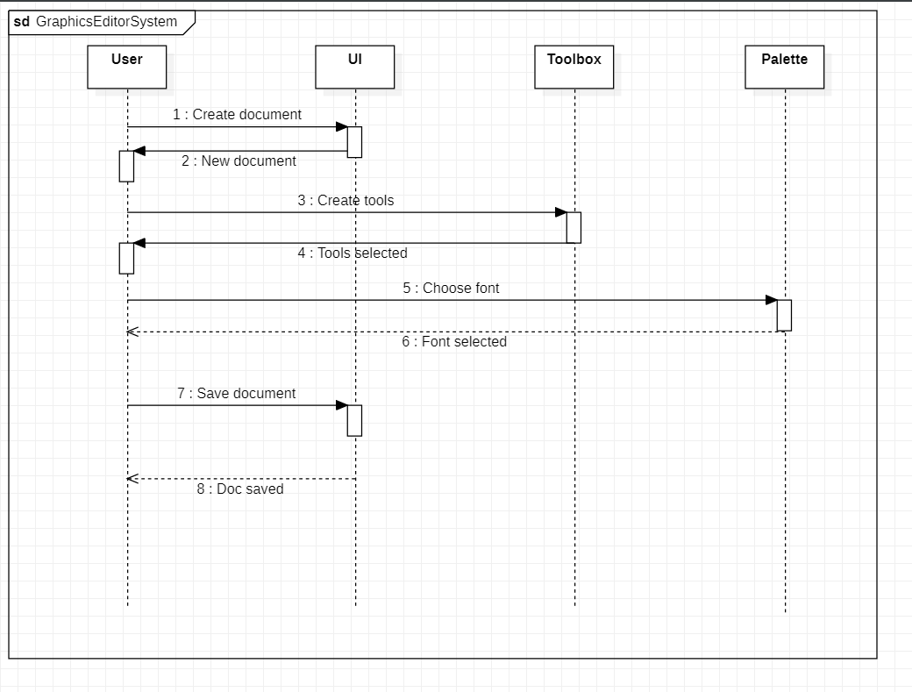Advanced

This includes checking the availability, booking, filling form, payment and confirmation.

## Activity Diagram

Simple

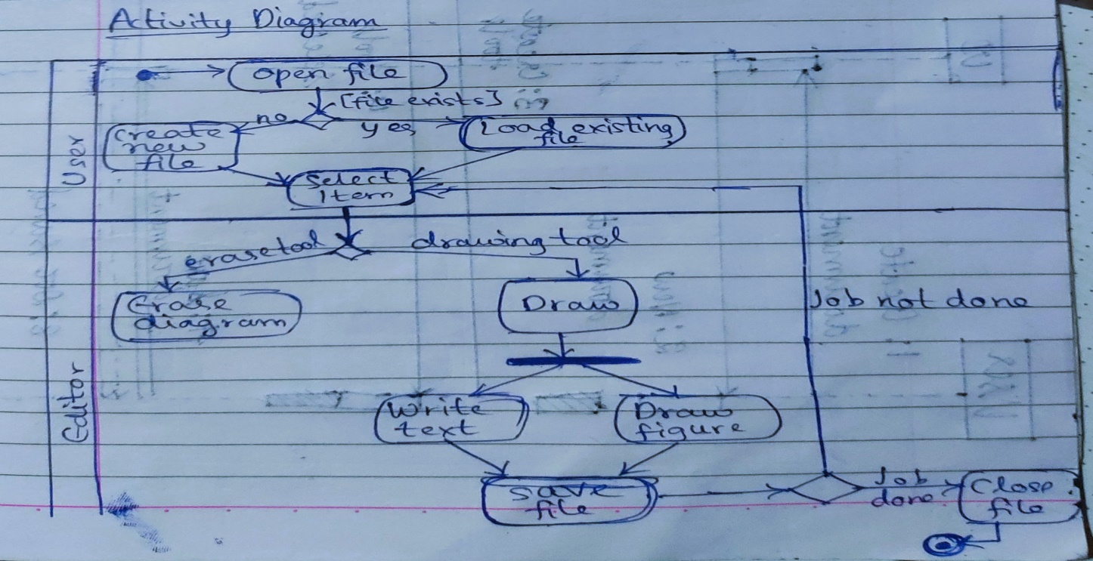

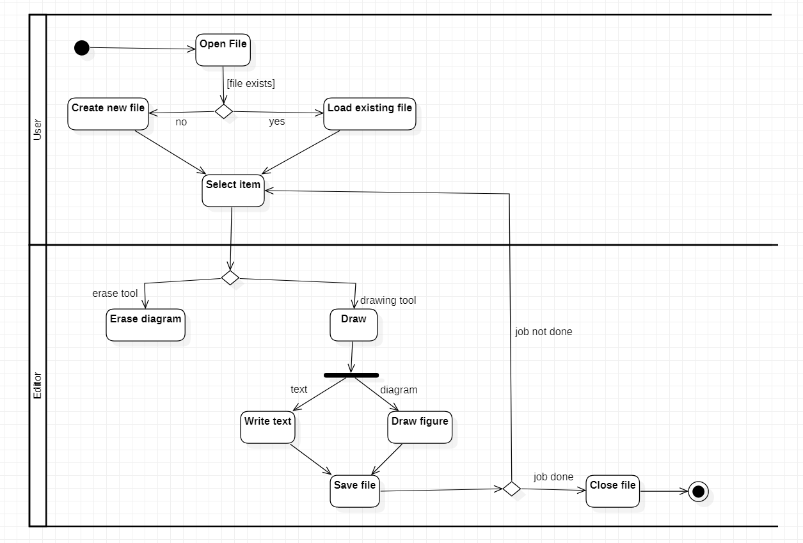Advanced

This includes checking the availability, booking, filling form, payment and confirmation.